Subject: english Total Marrks___50+10_____
Month : __ October_ ___ Obt. Marks: ___________
Theme/Unit: ____________ Grand total:___________
Objective/subjective:__________ Student ID : _________
Name ____________________ class: 2nd Section: ____________
Q # 1. Circle the correct option? /08
1) Miss Sana asked ________ students to make posters about good manners.
a | Grade one | b | Grade two | c | Grade three
2) Always drink water while______
a | Sitting | b | Standing | c | a & b
3) Momina is going to the__________with her mother.
a | School | b | Market | c | Park
4) I can be a pal when you feel________
a | Red | b | Yellow | c | Blue
5) Who________ was injured in an accident?
a A woman b A man |  |  |  | c | An old
6)The__________were enjoying the winter.
a | Ants | b | Grasshoppers | c | Butterfly
7) We use a question mark(?) at the end of a____________
a question b answer |  |  |  | c | A&b
8) First second, third etc are called
a | Nominal | b | Digit numbers | c | Ordinal numbers
Q# 2. Answer the following Questions? /8
- why should we always wash our hands before and after meal?

____________________________________________________________________________________________________________________________________________________

2.Did the man get serious injuries?
____________________________________________________________________________________________________________________________________________________

3.What are the qualities of a good friend?
__________________________________________________________________________
__________________________________________________________________________

4._what does momina buy from the garments shop?
____________________________________________________________________________________________________________________________________________________
Q#3 Look at the given picture and write the names of insects. /3
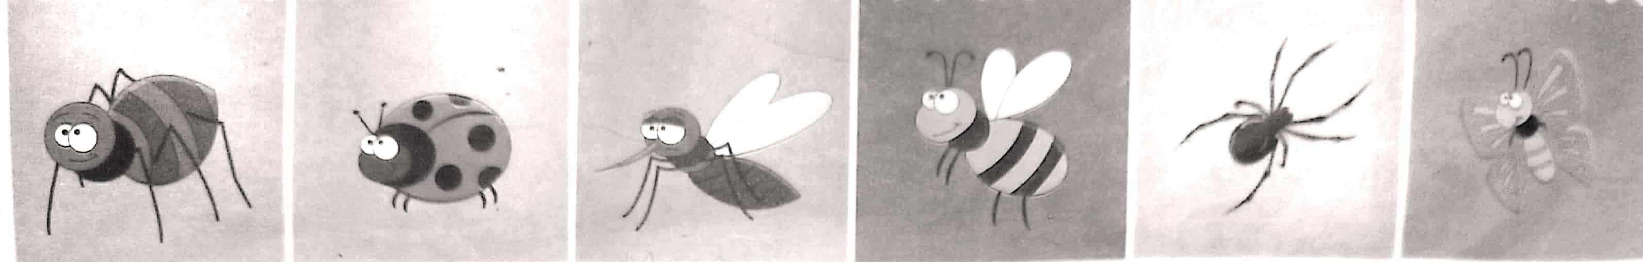

______________ _______________ ______________ _______________ ____________ _____________

Q#4.Creative Writing/4
Write four sentences about your best friend.

Q:5 Time to think. /3
List down the manners you adopt in your life.

______________________________________________________________________
______________________________________________________________________
______________________________________________________________________
______________________________________________________________________

Q:6.Comprehension Time . /3
Read the given title and table of contents.
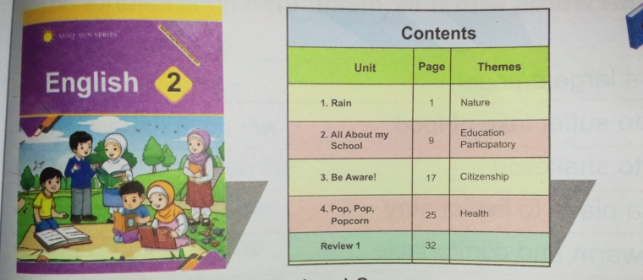

What is the title of the book? ______________________
write the name of unit 3. ______________________
Which unit is on page 25? ________________________

Q:7.Grammar /4
Circle the correct pronoun for each picture.
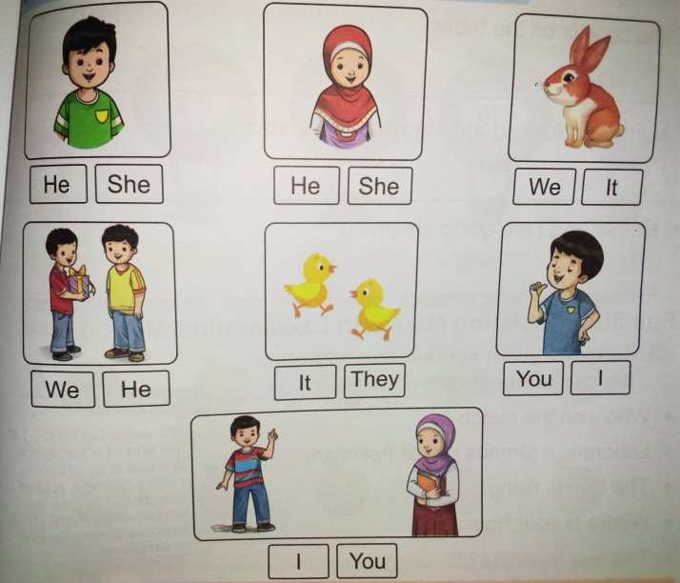

Q:8.Phonics Practice / 2
Identify one- and two-syllable words that rhyme. Write them in the correct columns.

Bike night butter like bandage clever duck fight luck manage never cutter

One syllable words | Two syllable words

Q:9.Define Proper Noun /2

______________________________________________________________________

Q:10.Let's get started. /2

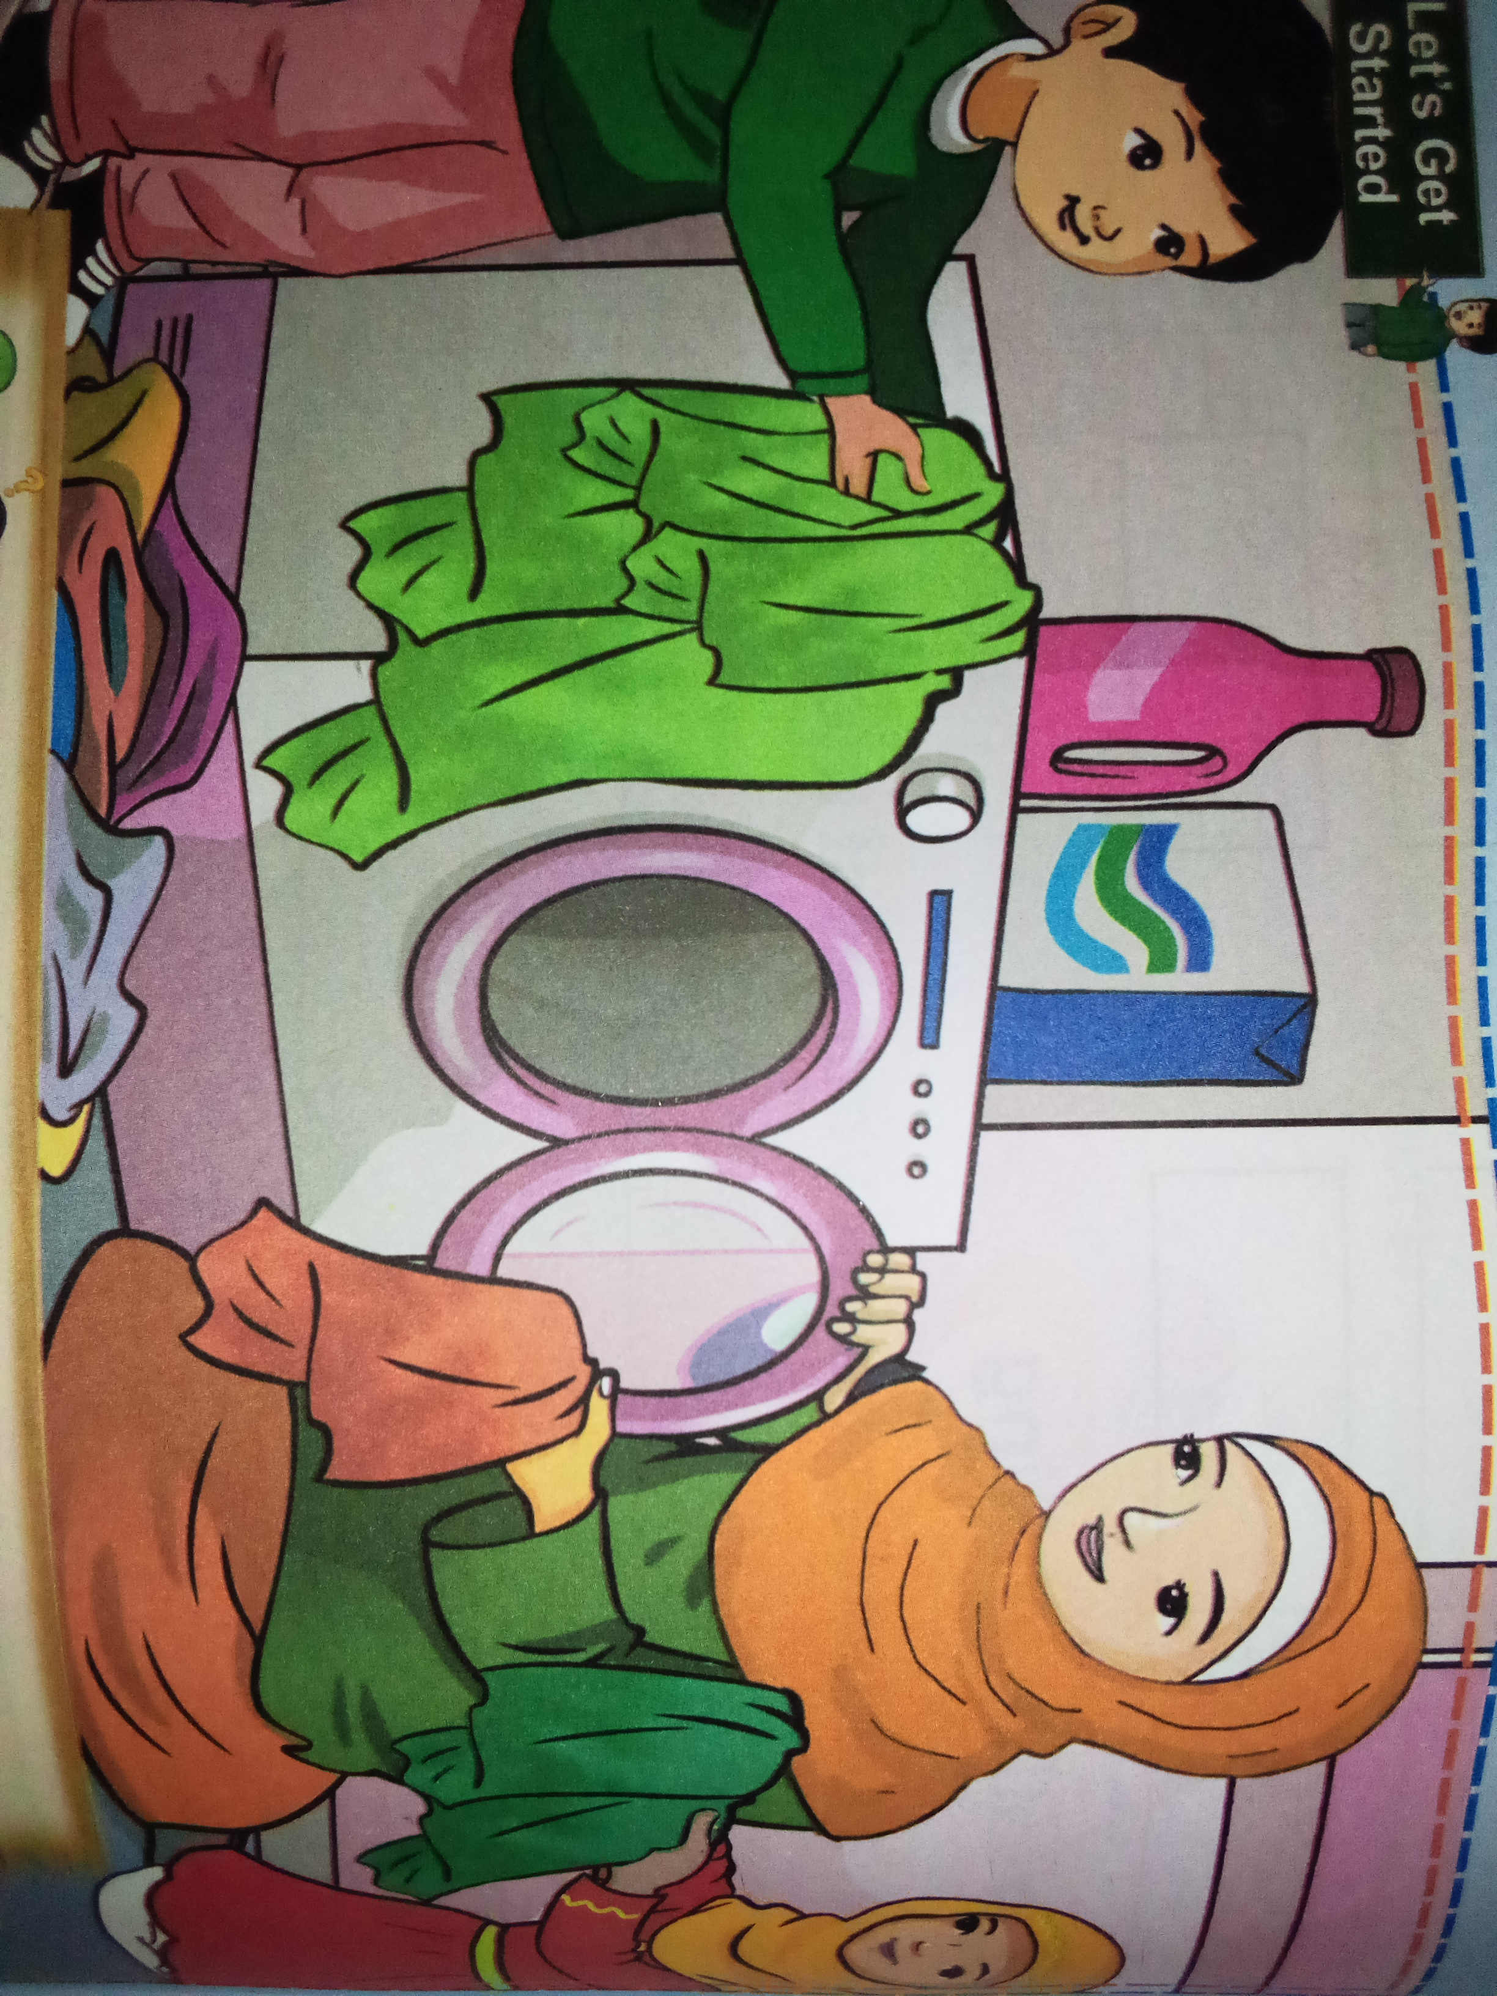

Q:What are tha children doing in the picture?
Ans: _____________________________________________________________________

Q11.Activity. /2
Arrange the words according to the first letter.
Pal feel blue single one
Ans: _____________________________________________________________________

Q12.Vocabulary /2

queue _______________
garment ________________
blue ________________
struck ________________

Q13.Guided Writing /3
Write six sentences on your favourite place to visit.
______________________________________________________________________
______________________________________________________________________
______________________________________________________________________
______________________________________________________________________
_______________________________________________________________________
_______________________________________________________________________

14.Creative writing /4
_____________________________________________________________________

______________________________________________________________________
______________________________________________________________________
_____________________________________________________________________

15.Dictation /10

______________________________________________________________________
______________________________________________________________________
______________________________________________________________________
______________________________________________________________________
_____________________________________________________________________

