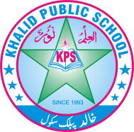
Subject: _________science Total Marks:. 52 _________________
Month Test: __ _____ ___ Obt. Marks: ________________
Theme/Unit: ___________ Grand total:_____10_________
Objective/subjective:__________ ID: ____________________
Name: ______________________ class: __6th___ Section: _______________
Answer these questions
- Define the atmosphere and name it’s layers . 2

- Why is water known as a universal solvent 2

- What do you know about heat energy?. 2

4. Differentiate between compound and mixtures.. 8

5. Differentiate between kinetic energy and potential energy. 4

- Describe the type of pulleys give example of daily life.8

- Differentiate between a solution and suspension .8

9. Define saturated and unsaturated solution. 4
11. Differentiate between real and virtual image. 4 12. Differentiate between a convex and concave mirror. 4

13. Write down the composition of air? /6

