Q1) answer these question 3*6= /18
Subject: ____s.st_________ Total Marks: ______52_
Month : __ October_ ___ Obt. Marks: ___________
Theme/Unit: ____________ Grand total:______100_____
subjective:__________ Student ID : _________
Name ____________________ class: __5th___ Section: ____________

1. What do you know about gandhara art?
_____________________________________________________________________________
_____________________________________________________________________________

2. Write the importance of Lahore resolution?

_____________________________________________________________________________
_____________________________________________________________________________

3. Name any five factor that affect the climate?

_____________________________________________________________________________

_____________________________________________________________________________

4. What is population density?

_____________________________________________________________________________

_____________________________________________________________________________

5. What minerals are found in plateaus of Pakistan?

____________________________________________________________________________

____________________________________________________________________________

6. What does the legend on a map describe?

____________________________________________________________________________

____________________________________________________________________________

Q2) answer that following question in detail. /12

1. What action can you take to minimise the effect of global warming?

____________________________________________________________________________
________________________________________________________________________________________________________________________________________________________
_______________________________________________________________________________________________________________________________________________________
________________________________________________________________________________________________________________________________________________________
________________________________________________________________________________________________________________________________________________________
___________________________________________________________________________
2. Write the factor that cause and increase in the population of Pakistan?

____________________________________________________________________________
________________________________________________________________________________________________________________________________________________________
_______________________________________________________________________________________________________________________________________________________
________________________________________________________________________________________________________________________________________________________
________________________________________________________________________________________________________________________________________________________
___________________________________________________________________________

Q no 6..
Did you know. /5
What are the coordinates of Makkah?
____________________________________________________________________________
________________________________________________________________________________________________________________________________________________________
_______________________________________________________________________________________________________________________________________________________
________________________________________________________________________________________________________________________________________________________

Q7) Recall and replay! /6
How can ocean current affect the climate?
____________________________________________________________________________
________________________________________________________________________________________________________________________________________________________
_______________________________________________________________________________________________________________________________________________________
________________________________________________________________________________________________________________________________________________________
________________________________________________________________________________________________________________________________________________________
Q#9: Write Five sentence about your favorite hero of Pakistan Movement. /6
_______________________________________________________________________________________________________________________________________________________
________________________________________________________________________________________________________________________________________________________
________________________________________________________________________________________________________________________________________________________

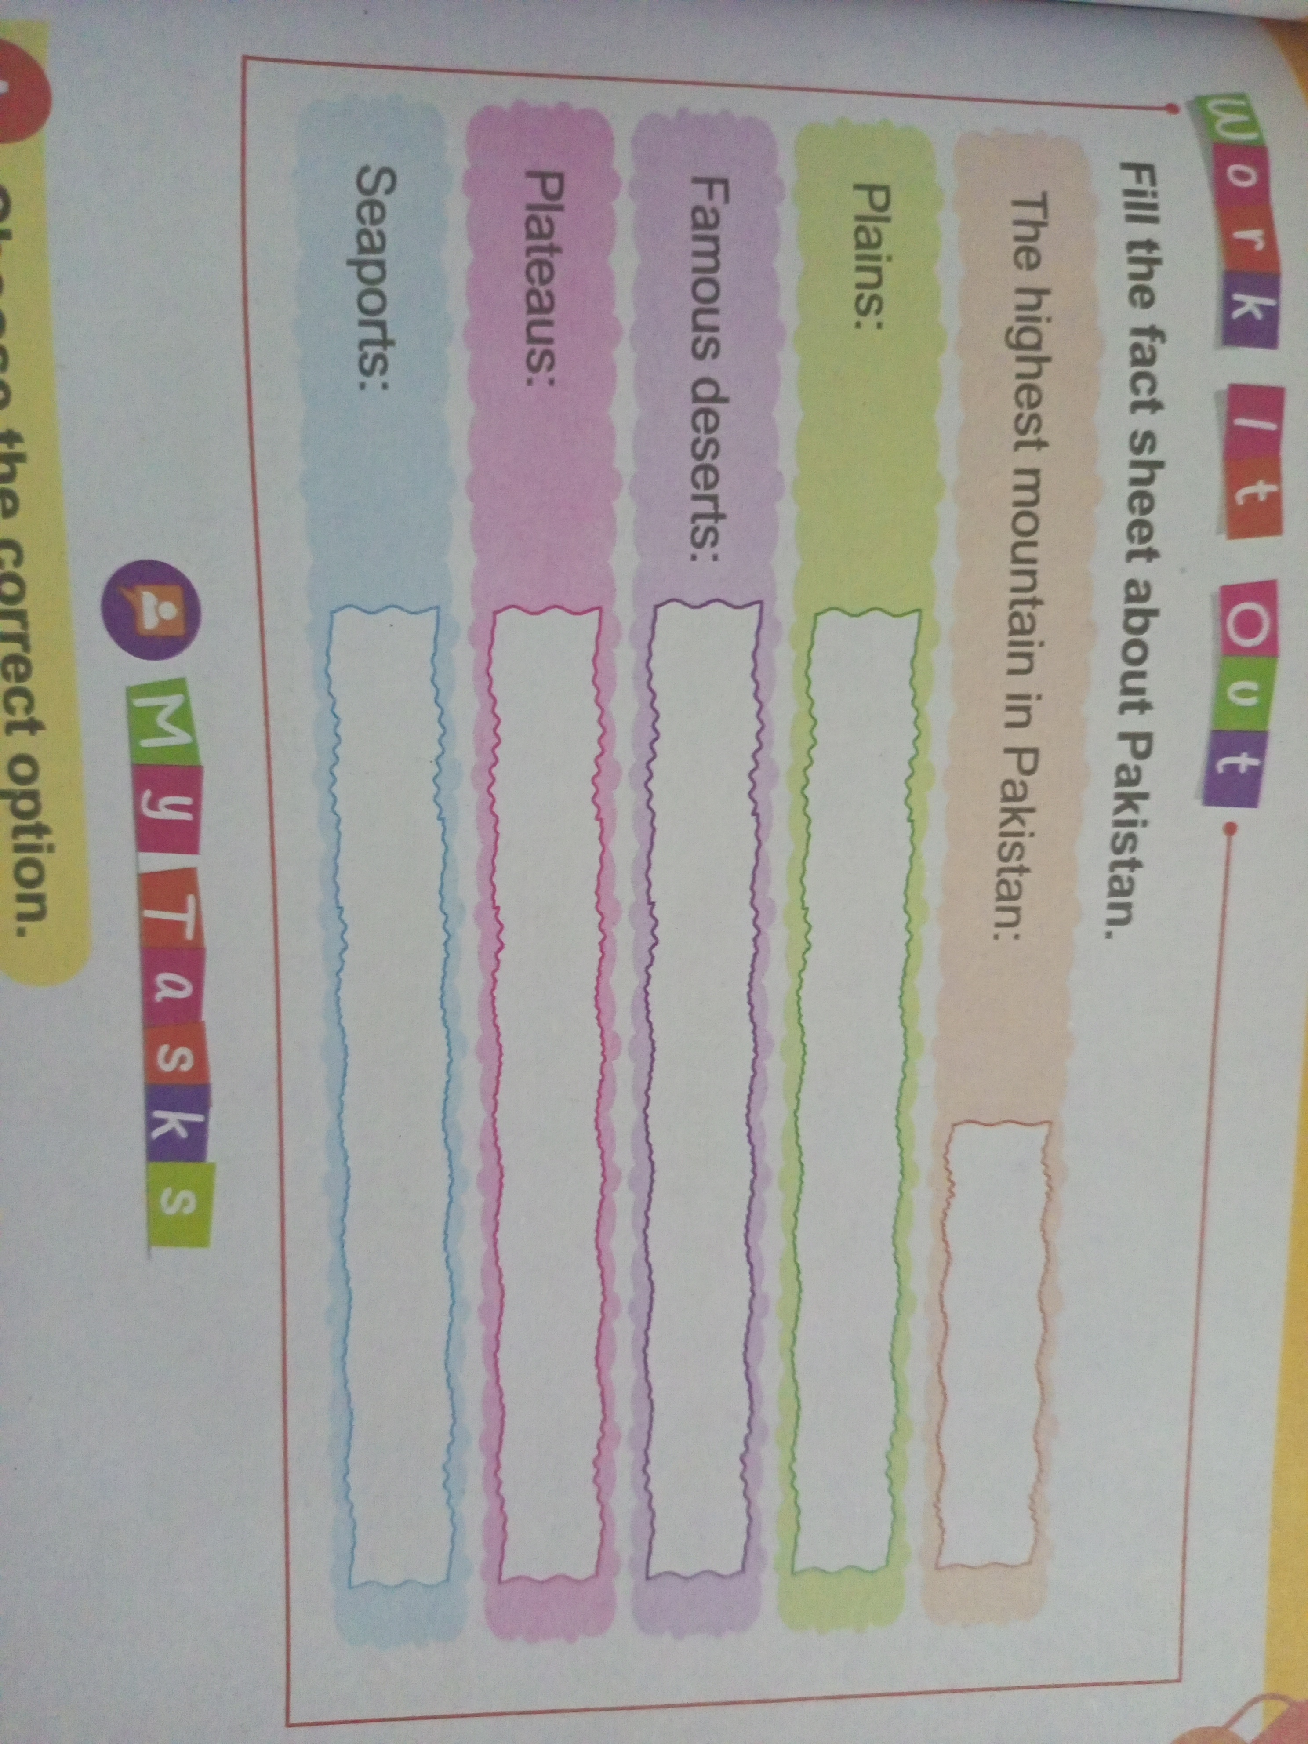
Q8) work it out. /5

