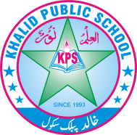
Q.no.1 Circle the correct options. /10
Subject: __General knowledge__ Total Marks: ___/50___
Month : __ October_ ___ Obt. Marks: ___________
Theme/Unit: ____________ Grand total:___________
Objective/subjective:__________ Student ID : _________
Name ____________________ class: _one_ Section: ____________
1.The Pakistani flag is
a) yellow and white b) green and pink c) green and white
2. We celebrate Independence Day on
a) 14th August b) 15th August c) 16th August
3.Saba goes to school in the
a) morning b) evening c) night
4. The_________ is the fastest means of transport
a) bicycle b) train c) aeroplane
5. At the railway station,we get on a
a) bus b) car c) train
6. Rabia bumped into a_______
a) bicycle b) car c) bus
7. At seaport, we board
a) bus stop b) a ship c) a car
8. To get on a bus, we wait at a/an
a) bus stop b) railway station c) air port
9.The founder of Pakistan is
a) Allama Iqbal b) Quaid-e-Azam c) Liaquat Ali Khan
10.The Pakistani flag has
a) the sun and crescents b) a crescent and a star c) the Moon and the Sun

Q. no. 2 Fill in the banks by using the word bank. /4
.

Neat, Clean, queue, head, run,

1. Stand in a ---------------------- before getting on a bus.

2. Do not --------------------- while crossing the road.

3. Students keep the playground ---------------- and ------------------.

4. Do not put your ------------------------- out of a moving car.
Q.no.3 Write True and False /5
1.Rabia was running across the road. ___________
2.You should get into a moving bus. ____________
3.Walk in the centre of the road. __________
4.Always hold an elder’s hand while crossing a road. __________
5.The bicycle is a slow means of transport. ___________
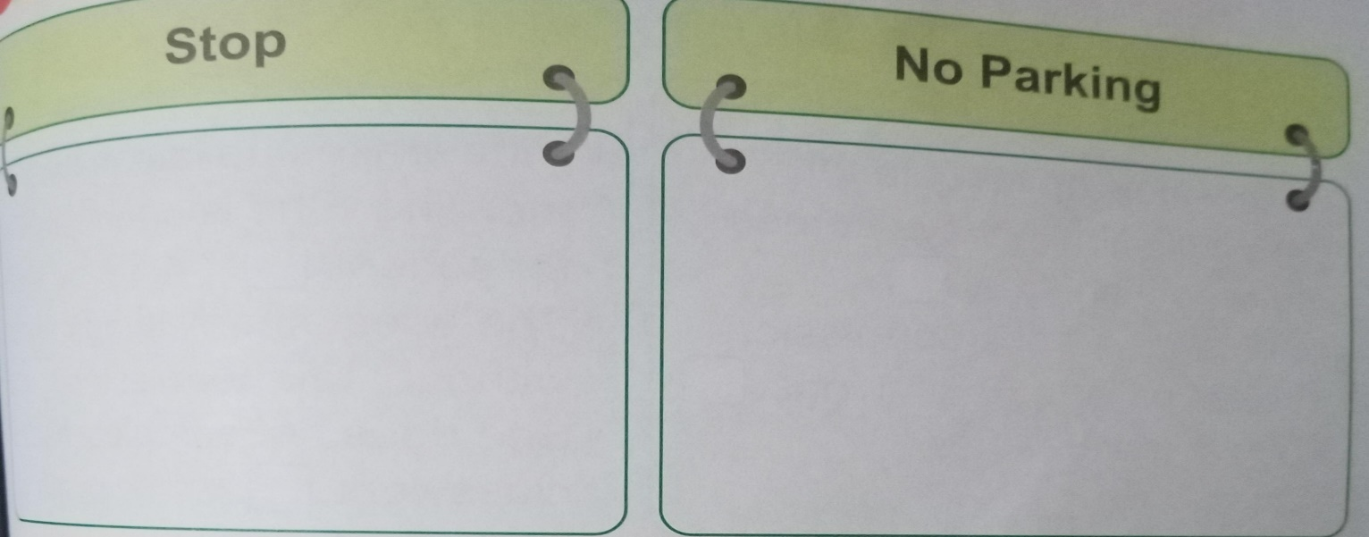
Qno.4 Draw traffic signs. /4
Qno.5 Answer the following Questions. /10
- Write the names of different means of transport?

_____________________________________________________________________

2. Who is in charge of Saba's school?

_____________________________________________________________________

3.Write the full name of Pakistan?

_____________________________________________________________________

4. . When did Pakistan come into being?

_____________________________________________________________________

5. What is a pavement used for?

_____________________________________________________________________

Q.no.6 Recall and reply! /2
1. Where do people get on the bus?

_____________________________________________________________________________

2. Did you know. /2.
What is the national dress of Pakistan?

_____________________________________________________________________
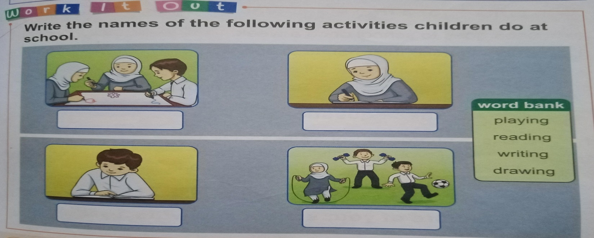

Q.NO 7 work it out . /4
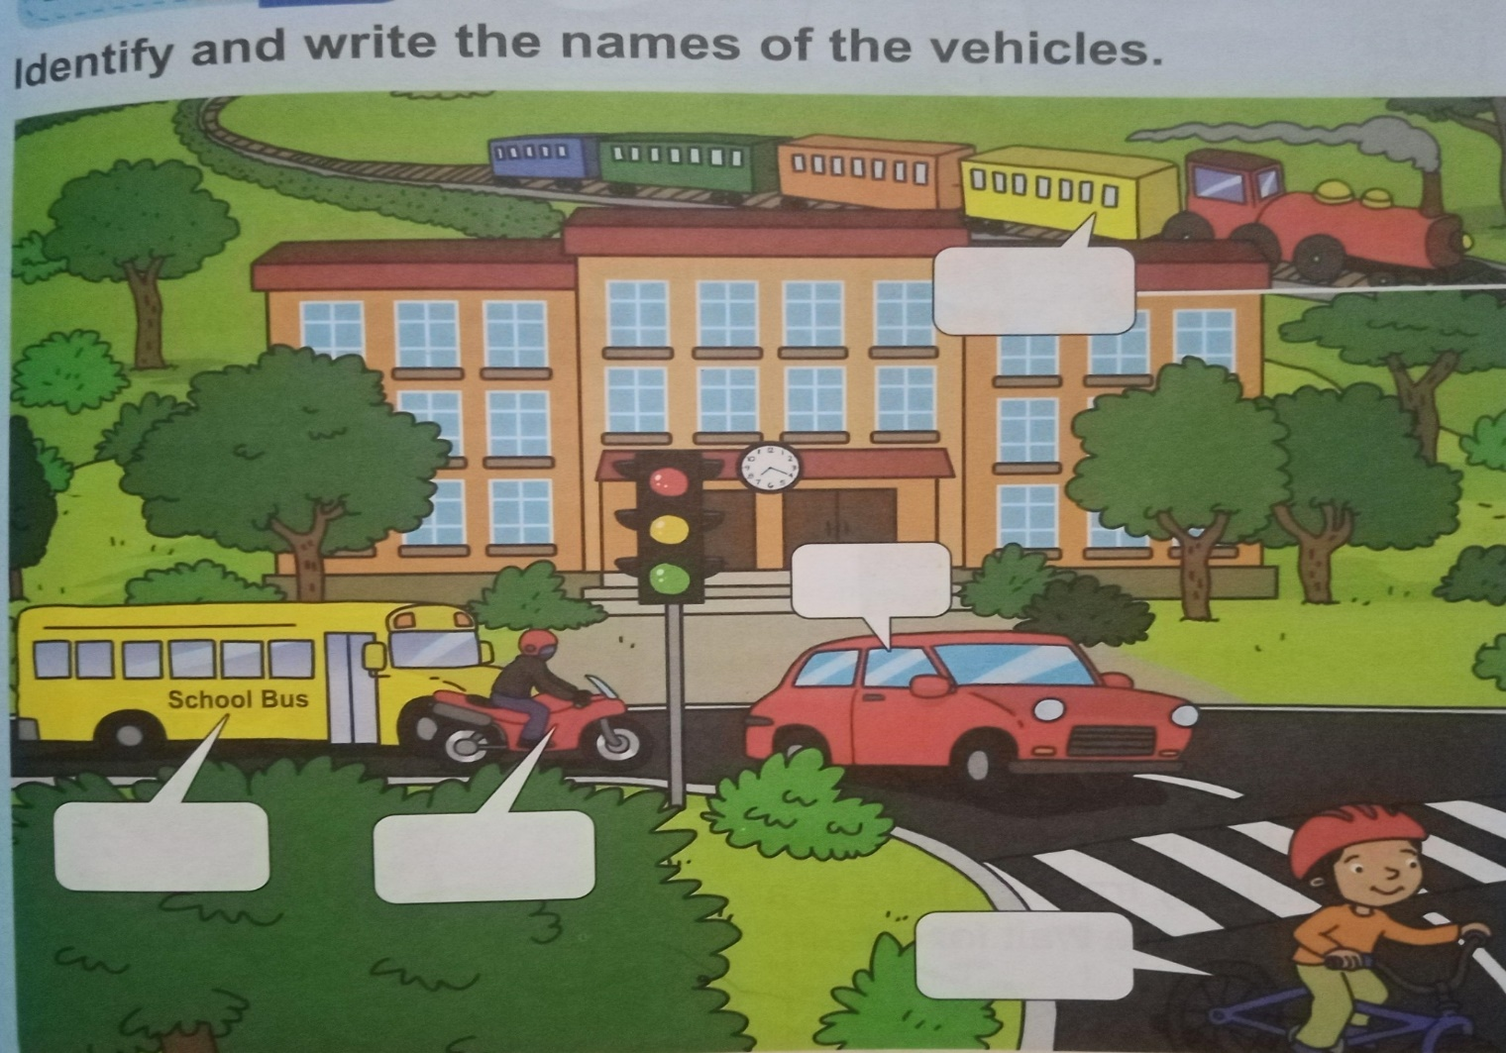
Q.no.8 Work it out /5

Q No. 9. Let's try it. Draw a picture of the national flower of Pakistan and
colour it. /4.

