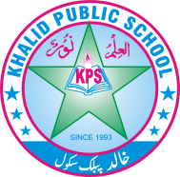

Subject: __General knowledge ____ Total Marks: __50____

Month : __ October_ ___ Obt. Marks: ___________

Theme/Unit: ____________ Grand total:___________

Objective/subjective:__________ Student ID : _________

Name ____________________ class: _Three _ Section: ____________



**Q No. 1 Encircle the correct option. /10.**

1. ------------ helps to build strong muscles in our body.

a. Meat b. Fruit and vegetables c. Milk

2. A healthy person should sleep ---------- hours daily.

a. 5 To 7. b. 6 To 8. c. 7 To 8.

3. Muslims demand for a separate country of their own at a meeting of the All India

Muslim League in Lahore in ------------.

a. 1914. b. 1947. c. 1940

4. Muhammad Ali Jinnah went to --------------- for higher studies.

a. Europe b. Britain. c. America

5. After doing his MA, Allama Iqbal taught at ------------------.

a.Government College Lahore. b. Sialkot c. Faisalabad

6. Fire was discovered by ----------------.

a. Jacob b. Charles c. Sanga

7. The fridge was invented by Jacob Perkins in ----------------.

a. 1734 b. 1834. c. 1934

8. Charles Babbage invented ---------------

a. The car. b. The television c. The computer

9. A sickle is used to cut ----------------.

a. Clothes b. Crops c. Wood

10. Example of wedge is -----------------.

a. Axes b. Cars. c. See saw

**Q NO 2.Write”True” and “False”. 05/**

1.Plants prepare their own food. (. )

2.The Quaid-e-Azam was the first governor general of Pakistan. (. )

3.Allama Iqbal was born in Lahore. (. )

4.The discovery of first was not important for human beings. (. )

5.Moder invention are useless. (. )

**Q No. 3. Fill in the blanks. /5.**

1. A healthy person should sleep ___________hours daily

2. The Quaid-e-Azam stood up for the _____________of Muslims.

3. A_________ is modern means of transport.

4.A sickle is used to cut ____________

5.A simple machine has made our work_______________.

**Q No. 4. Answer the questions. /10.**

1. List a few good qualities you like in the Quaid e Azam.

2:Write the names of three tools people used in the old days?

3. How different are the old and new means of transport?

4. .What is a balanced diet?

5. Why do we use simple machines?

**Q No. 5. Match these animals with their types. /6.**

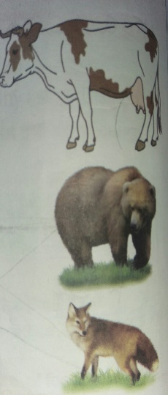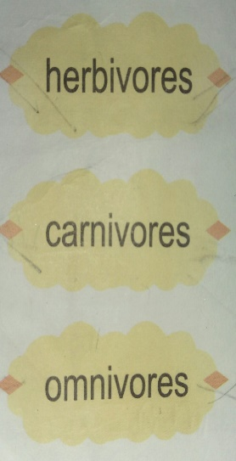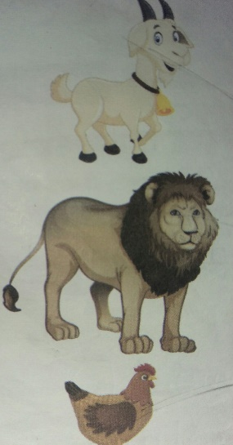

**Q No. 6. Work it out. /6.**

**Look at the tools in the given pictures. Write the names and uses of these**

**tools.**

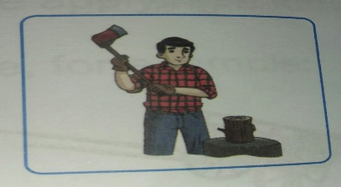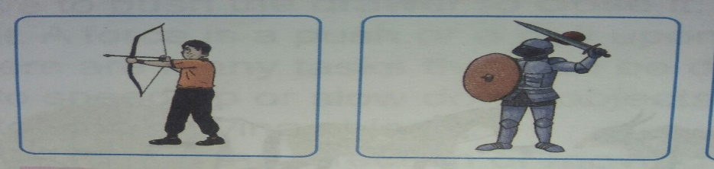

Name and Uses.

1 ------------------------------------------------------------------------------------------------------------------------

2. --------------------------------------------------------------------------------------------------------------------------

3. --------------------------------------------------------------------------------------------------------------------------

**Q No. 7. Recall and reply. /2.**

When was Allama Muhammad Iqbal born?

**Q.no.8 Did you know? /3**

Q. Who was designed first petrol-run car and when?

**Q No. 9. Our Task. /3.**

Which force is being used to pull or push? Arrange the tasks in the

correct columns.

