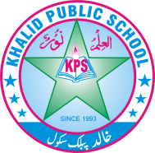

Subject: __S.st___________ Total Marks: ___30_______

Month : __ October_ ___ Obt. Marks: ___________

Theme/Unit: ____________ Grand total:____50_____

Objective/subjective:__________ Student ID : _________

Name ____________________ class: __4th___ Section: ____________



**Q#1 Answer the Questions briefly: /10**

1.write the contributions of matramma Fatima jinah to the Pakistan /2

2.How did Sikh rule end in Khyber pakhtunkhwa? /2

3.Defines the terms “continent” and “ ocean” /2

4.Name some western Mountains: /2

5.What are the main crops of Pakistan? /2

**Q.2 Answers the following Question in Detail:**

**1. What do you know about the political personalities of Khyber Pakhtunkhwa? Describe any two**. /5

**2. Why are plains important for a country? /5**

**3. Why are plains are important for a country? /5**

**4. Compare the lifestyles of people living in different physical regions of Pakistan? /5**