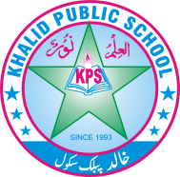
Subject: _English____________ Total Marks:35+10
Month : __ October_ ___ Obt. Marks: ___________
Theme/Unit: Unit No 7 to 10__ Grand total:_
Objective/subjective:__________ Student ID : _________
Name ____________________ class: One___ Section: ____________
Q:1Answer the given questions. /5

1.Name any five blessings of Allah?
__________________________________________________________________________________________________________________________________________________________

2.Do you like Eid festivals?Why?

__________________________________________________________________________________________________________________________________________________________

3. How should we take care of earth?

__________________________________________________________________________________________________________________________________________________________

4.Why was Blakie unhappy with his looks?
__________________________________________________________________________________________________________________________________________________________
5.How was Basit wasting water?
__________________________________________________________________________________________________________________________________________________________
Q:2 Write the names of two fruits and two vegetables. /4

Fruits Vegetables
_____________________ ____________________
_____________________ ____________________

Q:3 Rewrite and punctuate the given sentences using a
question mark. /3
1.Is this your book
_
____________________________________________________________________________

2.What are you doing

_____________________________________________________________________________

3.Are you playing in the park

_____________________________________________________________________________

Q:4 Read the words with their meanings. /2
part ______________________

quickly ______________________

Q:5 Define: Adjective of quality . /2
__________________________________________________________________________________________________________________________________________________________

Q:6 Name two objects you see at home and at school. /2

At home _________________ ______________________

At school __________________ ______________________

Q:7 Which is your favourite animal? /2

___________________________________________________________________________

Q:8 Fill in the blanks with 'is , are or 'am'. /5
1. They ______________________ working.
2. This _______________________ a school.
3 .I _______________ a woman.
4. I _______________ cooking.
5. It _______________ a horse.

.
Q :9: Phonic practice. /2
Match the digraphs of with the correct words.
Phone this thumb photo

Ph th

Q:10:Guided Writing. /3
Make a list of three items you find in your garden.
__________________________
___________________________
___________________________
Q:11 Look at the pictures. Fill in the missing letters for each of the
following parts of the body. /3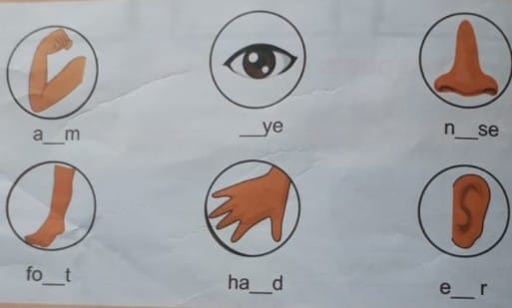

Q:12 Creative writing /2

Q:13 Dictation /10

Word | Meaning | Word | Meaning

