

Subject: ___Science ____ Total Marks: ____52 ___

Month : __ October_ ___ Obt. Marks: ___________

Theme/Unit: ____________ Grand total:___________

Objective/subjective:_Subjective _ Student ID : _________

Name ____________________ class: _Five _ Section: ____________



Q No. 1. Answer the following questions. /15.

1. Why are unpleasant sounds bad to hear? Explain.

2. Why does your hair lift up when you comb it in cold and dry weather?

3. Describe some uses of magnets in daily life.

4. Which layer of the earth forms the magnetic field of the Earth ? Explain.

5. How does sound travel?

Q No. 2. Answer the following questions in detail. /16

1. Two astronauts are floating close to each other in space. Can they talk

to each other with out using a special device? Give reasons?

2. Describe the structure of an atom.

3. How does the Earth behave like a bar magnet?

4. Discuss the structure of the mantle and core of the Earth in detail.

Q No. 3. Science Titbit. /5

What is an echo? How do bats use it?

Q No. 4. Work it out. /9

Label the structure of the Earth and write the thickness of each layer

of the Earth.

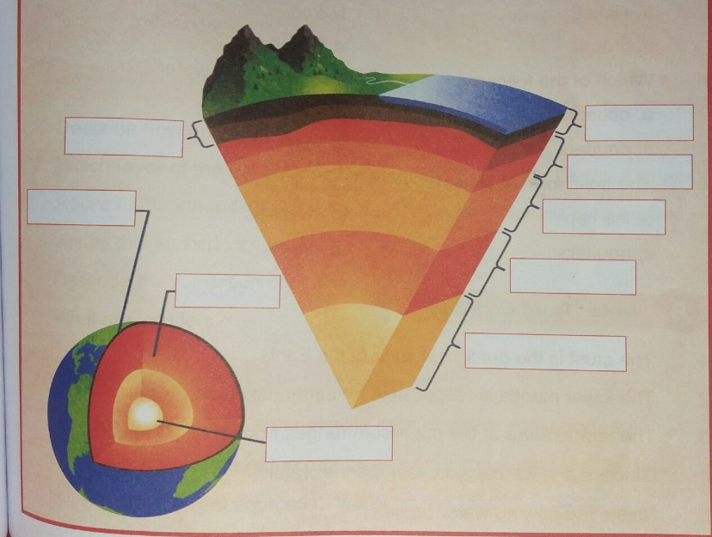

Q No. 5. Activity -1. /3.

Descriptions are given. Write the term in box against each description.

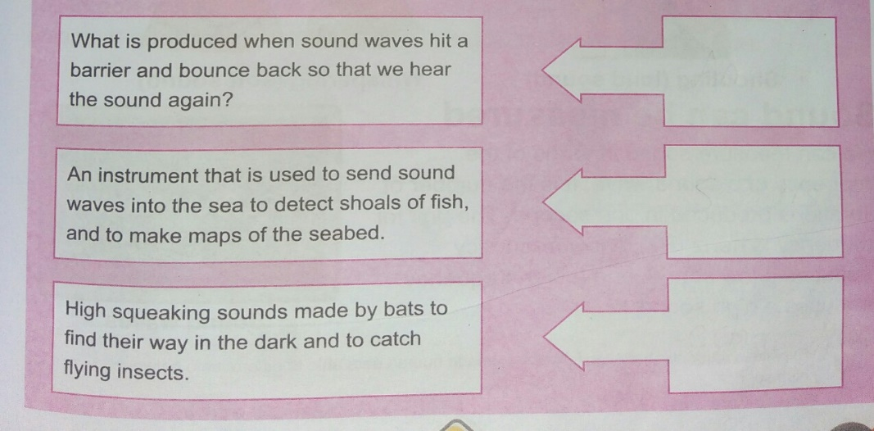

Activity -2. /4.

There are two cans -A is an Aluminum Can and B is an Iron Can.

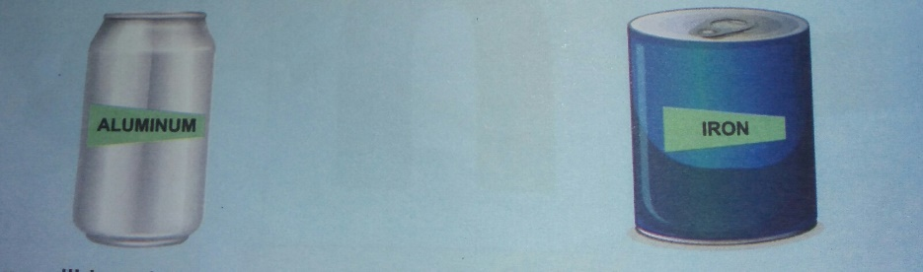

A. Which can will be picked up by a magnet? Give reasons.

B. Which can will not be picked up by a magnet? Give reasons.