Q.No.1: Encircle the correct answer. (5).
Subject: English Total Marks: 50
Month: __ October_ ___ Obt. Marks: ___________
Theme/Unit: ____________ Grand total: 50+10
Objective/subjective: __________ Student ID: _________
Name ____________________ class: 3rd_____ Section: ____________
1) The Neelam valley is located.
(a) Muzaffarabad (b) Abbottabad. (C)Murree

2) The synonym of beeter is.
(a) bad (b) bitter. (c) good

3) Minsa collects things for making a:-
(a) sock puppet (b) pencil holder (c) card

4) The word (important) have syllables.
(a) 2 (b) 5 (c)3

5) I am resting ----------i am tired.
(a) but (b) because. (c) with

Q.No.2: Write “present”, “past” or “future” tenses for each sentences. (5)
1) They play football everyday: ________________
2) Amina and Babar went to the shopping mall yesterday: _________________
3) We will go to the zoo tomorrow: ___________________
4) He bakes cakes in the morning: ________________
5) She will go to the school tomorrow: _______________

Q No.3: Define of "Antonyms". (2)

Q.No 4: Answers these following questions: (6)
(1) Which animal do you like? Why?
_____________________________________________________________________
_____________________________________________________________________

(2) .Write the names of famous fruits of Neelam Valleys.

(3) why are sports important ?
_____________________________________________________________________
____________________________________________________________________

Q.No.5. While reading /2
what is your favourite sport and why?

_____________________________________________________________________

Q.No.6:-Look at the given pictures and complete the pairs of homophones:-. (6)

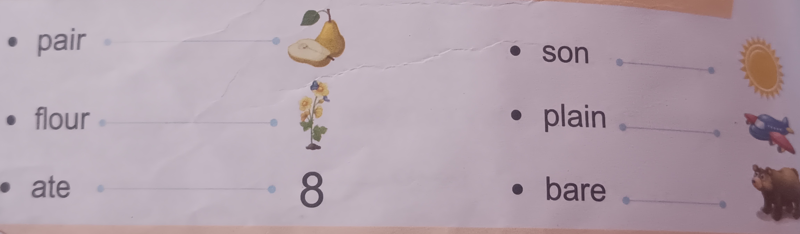

Q#7. Write a short paragraph about the recent sports day at your school in your own words /5
.

_____________________________________________________________________
_____________________________________________________________________
_____________________________________________________________________
_____________________________________________________________________
_____________________________________________________________________
_____________________________________________________________________
_____________________________________________________________________
_____________________________________________________________________
_____________________________________________________________________
_____________________________________________________________________
Q.No.8.Put the given common and proper nouns in the correct places. (4)
day, drink, Monday, Mithu, mouse, girl, Karachi, Rabbia.
Common Noun: _________ ,__________,_________,_________,
Proper Noun: _________, __________ ,_________,_________,
Q.No.9.Arrange the given words alphabetically according to the second letter. (3)
Come Camel Cloth Cup Circle __________,_______,_______,________,_________
Q.No.10.Tick the correct synonyms for the underline words. (3)
1) Let's start with the first lesson. (Begin / end)
2) The train will come on the time. (Depart / arrival)
3) She distributes money among the poor. (clothes /cash)
Q#11. Fill in the blanks with the correct verbs. /4
1. Minsa ………… (is , am ) eating an apple.

2. They …………. ( is , are ) reading books.

3. she ………. ( is , are ) colleting flowers.

4. I ……… ( is , am ) going to buy potatoes.

(5)
Q.No.12: Creative writing:

Dictation./10

