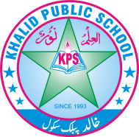
Q.no.1 Circle the correct options. /10
Subject: __General knowledge__ Total Marks: ___/50___
Month : __ October_ ___ Obt. Marks: ___________
Theme/Unit: ____________ Grand total:___________
Objective/subjective:__________ Student ID : _________
Name ____________________ class: _Two_ Section: ____________
1. A camel usually lives
a) in a desert b) on mountains c)in a forest
2. A caterpillar is a baby of
a) a butterfly b) a frog c) a lion
3. Trees provide
a) iron b) plastic c) fruits
4. Trees take it out
a) oxygen b) carbondioxide c) clouds
5. The biggest natural resource of heat and light is
a) an electric bulb b) the moon c) the sun
6. The natural source of light is
a) a lamp b) a star c) an electric bulb
7.The teacher asked students to
a)fight b) share c) yell
8. Mrs Sajid was
a) worried b) happy c) amazed
9. A person who makes wooden objects is called
a) a doctor b) a carpenter c) a teacher
10. A person who puts out fires is called
a) a firefighter b) an engineer c) a plumber
Q.no.2 Answer the following questions. /8
1. List four professions.
________________________________________________________________________________________________________

________________________________________________________________________________________________________

2 Write two features of land animals?
________________________________________________________________________________________________________________________________________________________________________________________________________________

3. Why are forests important?
________________________________________________________________________________________________________________________________________________________________________________________________________________
4: Name the Natural sources of water?
________________________________________________________________________________________________________________________________________________________________________________________________________________

Q.no.3 Recall and reply! /3
Q. What did the teacher advise students?
________________________________________________________________________________________________________________________________________________________________________________________________________________________________________________________________________________________________________________________

Q.no.4 Did you know? /3
Q. What was the professions of Hazrat Adam and Hazart Noah?

Q.no.5 Fill in the blanks. /4
Food farmer clothes crops
1. Arif's father is a ___________.
2. Wheat is the basic __________ for people.
3. People process __________ to make different products.
4. We make __________ from cotton

Q.no.6 Write True and False. /5
1. Ayan promised he would always waste water. ________
2. Trees are home to many birds. _______
3. Wood is used to make many things. _______
4. We should always cut down trees. _______
5. Plant need sunlight to grow. _______
Q.no.7 /4
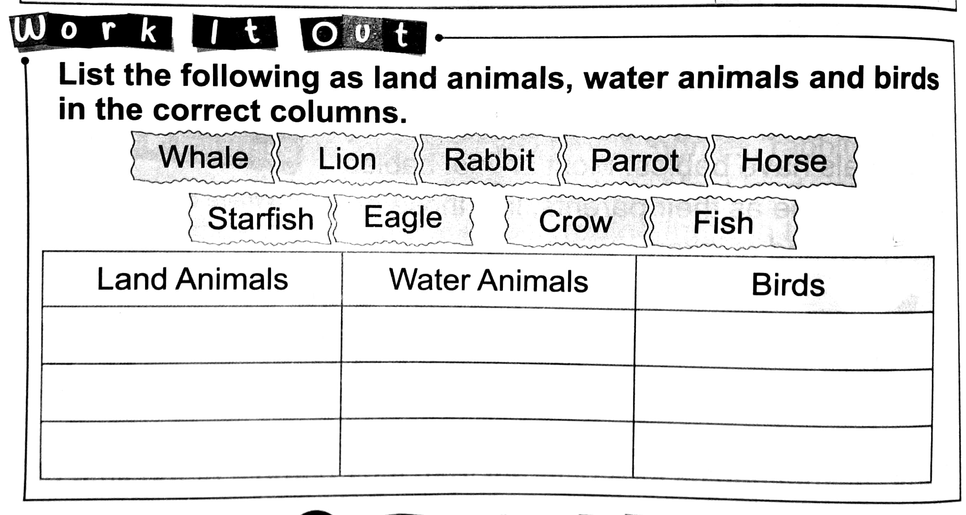

Q.no.8 Match the columns. /4
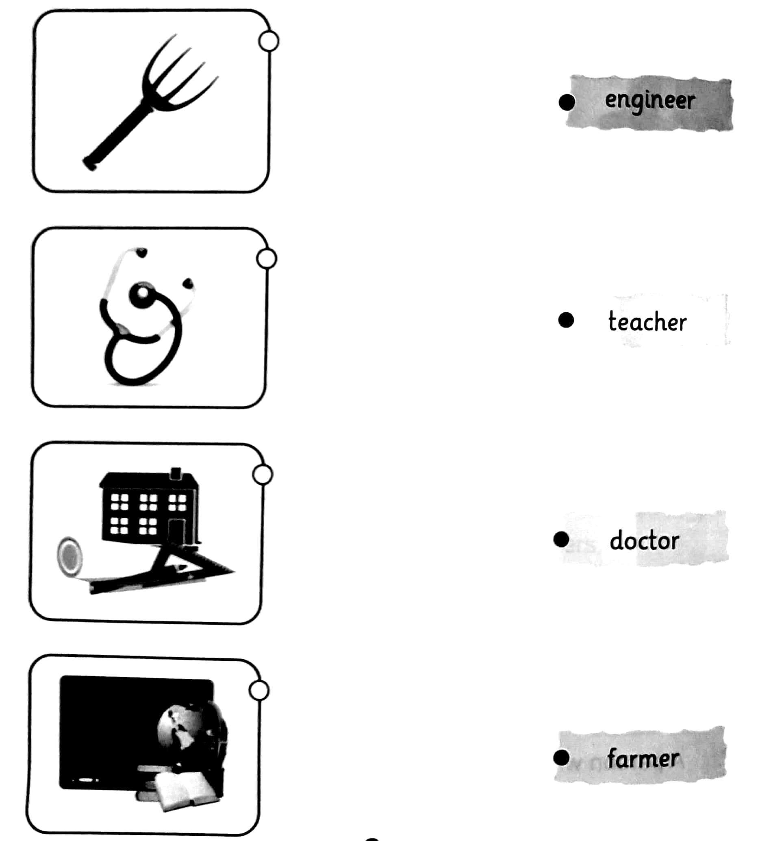
Q.no.10 /6
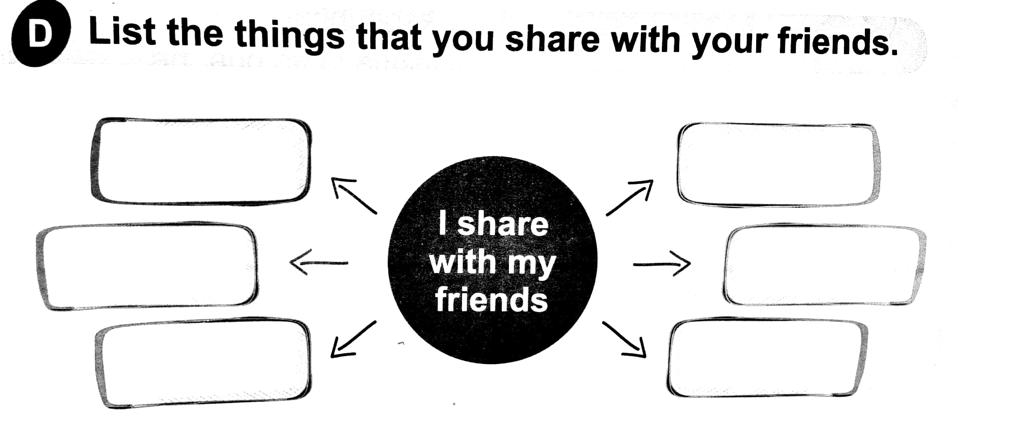

Q.no.11 /3
