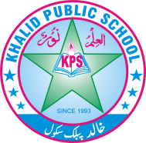
Subject: ___English __________ Total Marks: __42+10_______
Month : __ October_ ___ Obt. Marks: ___________
Theme/Unit: ____________ Grand total:50±10_________
Subjective:__________ Student ID : _________
Name ____________________ class: _4th__ Section: ____________
# 2. Answer the following Questions? /8
1. Why did children love to visit Dr. Faisal?
__________________________________________________________________________________________________________________________________________________________

2.Where did the poor fishermen live?
__________________________________________________________________________________________________________________________________________________________

3.How did the sparkling fish help Bilal?
__________________________________________________________________________________________________________________________________________________________

4.How did the event start the next day?
__________________________________________________________________________________________________________________________________________________________
Q#4. Phonics practice. /4
Read the words given in the world bank below and put them into their respective columns.
Holiday. Government. Factory. Businessman. Festival. Ingredients
Vegetable. Championship

Three syllables | Four syllables

Q. 4 Time to think:-
Write down five benefits of good health. /3
_____________________________________________________________________________
_____________________________________________________________________________
_____________________________________________________________________________
_____________________________________________________________________________
_____________________________________________________________________________
_____________________________________________________________________________
_____________________________________________________________________________
_____________________________________________________________________________
Q. 5 Grammer. /3
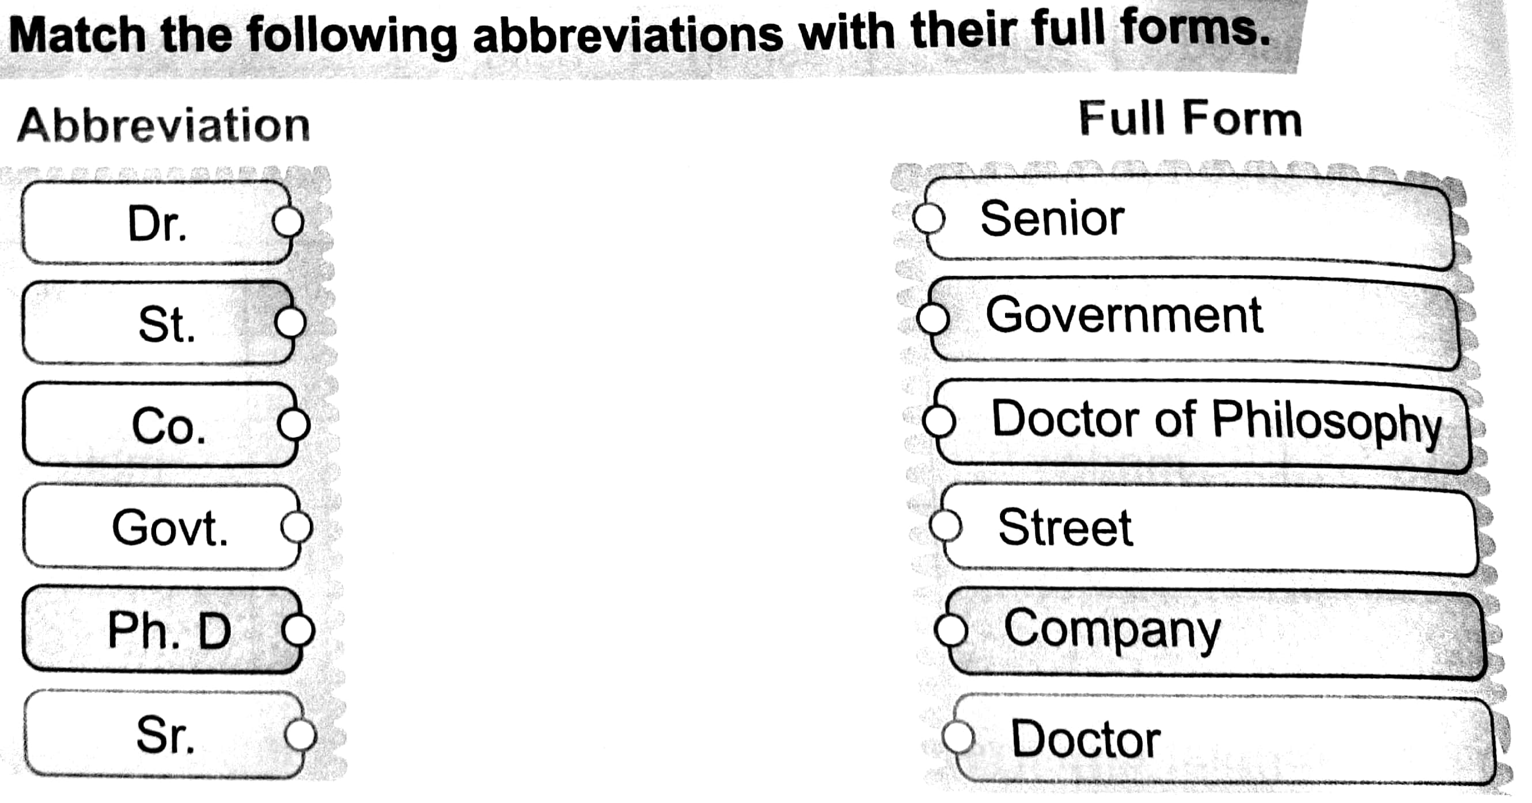

Q. 7 writing: /4
Write a Letter to your father asking him to send you money for buying new books.

_____________________________________________________________________________
_____________________________________________________________________________
_____________________________________________________________________________
_____________________________________________________________________________
_____________________________________________________________________________
_____________________________________________________________________________

_____________________________________________________________________________

_____________________________________________________________________________
_____________________________________________________________________________
_____________________________________________________________________________

_____________________________________________________________________________

Q#5. Define adjective and adverb. /2

_________________________________________________________________________________________________________________________________________________________________________________________________________________________________________________________________________________________________________________________________________________________________________________________________
Q#6 Share the names of some cultural festivals of Pakistan./2
_______________________________________________________________________________________________________________________________________________________________________________________________________________________________________
_____________________________________________________________________________

Q. 15 Creative writing: _________________________ /4
__________________________________________________________________________________________________________________________________________________________
__________________________________________________________________________________________________________________________________________________________
__________________________________________________________________________________________________________________________________________________________
_____________________________________________________________________________
__________________________________________________________________________________________________________________________________________________________

Q# 16. Dictation? /10
Words | Meanings

