Q#1: Encircle the correct answer. /28
Subject: _S.st___ Total Marks: ___/48____
Month : __ October_ ___ Obt. Marks: ___________
Theme/Unit: ___6 to 11 ___ Grand total:____/100___
Objective/subjective:__________ Student ID : _________
Name ____________________ class: __5th___ Section: ____________
1) Rome was founded by its first king:
a) Ramses. b) Athens. c) Romulus. d) Ashoka.
2) Gilgit-Baltistan joined Pakistan in 1947 on
a) 1May. b) 1july. c) 1September. d) 1 November.
3) What describe a map?
a) The title. b) The map scale. c) The border. d) The legend.
4) The largest desert of Pakistan
a) Nara. b) Kharan. c) Thar. d) Thal.
5) Deforestation causes an increase in
a) Carbon dioxide. b) nitrogen. c) Water vapor. d) oxygen.
6) In 1950, the world population was around.
a) 1billion. b) 2.6 billion. c) 6 billion. d) 7.7billion.
7) When a river rises high above its surface level and spread out on dry land, it is
a) an earthquake. b) a cyclone. c) a hurricane. d) a flood.
8) The upper Indus plains consist most of
a) Punjab. b) Sindh. c) Balochistan. d) KPK.
9) The total number of lines of longitude is
a) 60. b) 90. c) 180. d) 360.
10) How many types of map scale are there?
a) five. b) two. c) four. d) three.
11) The Olympics games were first held in 776 BCE in
a) Sparta. b) Athens. c) Olympia. d) Marathon.
12) The world's second highest peak
a) Naga parbat. b) K2. c) Tirich Mir. d) Mount Everest.
13) It can change by the day, by the hour and even by the minute.
a) climate. b) weather. c) environment. d) greenhouse gas
14) Currently, in 2021, the world population is around
a) 7.7 billion. b) 2.6 billion. c) 6 billion. d) 1 billion

Q#2: Fill in the blanks. /05
1) For a better life style, people move from _______________ to cities.
2) There are ____________ lines of latitude.
3) ________________ used the word 'nation' for Muslim of subcontinent.
4) There are ___________ time zones of the world.
5) Pakistan's highest peak is _____________.

Q#3: Write T for true and F for false. /05
1) The population of Pakistan is decreasing rapidly. _________
2) The hight of K2 is 7,960 meters above the sae level. _________
3) The Compass rose on map shows cardinal direction. _________
4) People of Jammu and Kashmir wanted to join Pakistan. __________
5) The Civilization of Ghandhara started in 600 BCE. _________

Q#4: Match the lines with their longitude and latitude. /6

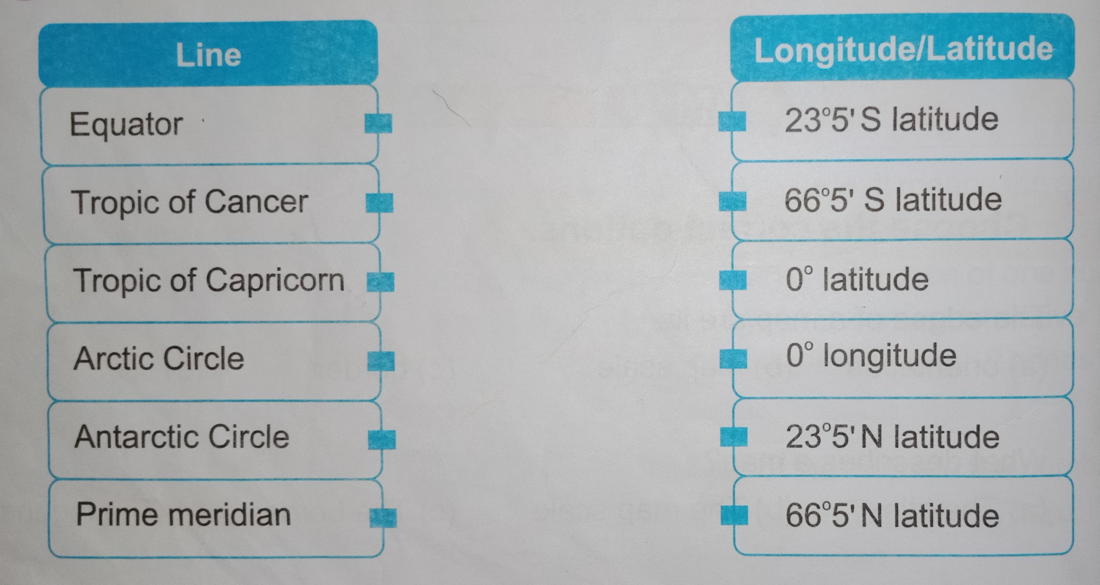

Q 5. Calculate the population density of your classroom. /4

total number of students=

total area of the classroom ( length × width )=
squre meters.

