Q.no.1 Answer the following questions. /10
Subject: ___English____ Total Marks: __/52___
Month : __ October_ ___ Obt. Marks: ___________
Theme/Unit: ____________ Grand total:__100+10____
Subjective:__________ Student ID : _________
Name ____________________ class: _5th__ Section: ____________
1. Why was Hassan upset?
_____________________________________________________________________________
_____________________________________________________________________________
2. Find the names of different flowers in the poem(A calendar).
_____________________________________________________________________________
_____________________________________________________________________________
3. Did the old man fool Hussain or not?
_____________________________________________________________________________
_____________________________________________________________________________
4. What is Internet stranger danger?
_____________________________________________________________________________
_____________________________________________________________________________
5. Why were the animals in the jungle worried?
_____________________________________________________________________________
_____________________________________________________________________________
Q.no.2 Define “Adverbs of manner”. /3
_____________________________________________________________________________
_____________________________________________________________________________
_____________________________________________________________________________
_____________________________________________________________________________

Q.no.3 While reading /4
Q. What do you think about the act of Hussain?
_____________________________________________________________________________
_____________________________________________________________________________
Q.no.4 let’s get started /3
Q. How do you save yourself from a dangerous situation?
_____________________________________________________________________________
_____________________________________________________________________________
Q.no.5 Vocabulary /3
Words | Meanings
Goodness
Fool
.trustworthy
Q.no.6 Creative writing /5
Write a narrative paragraph about your mother .
_____________________________________________________________________________
_____________________________________________________________________________
_____________________________________________________________________________
_____________________________________________________________________________
_____________________________________________________________________________
_____________________________________________________________________________
_____________________________________________________________________________
_____________________________________________________________________________
_____________________________________________________________________________
_____________________________________________________________________________

Q.no.6 Guided Writing /5
Fill in the given mind map about the benefits of using the Internet.
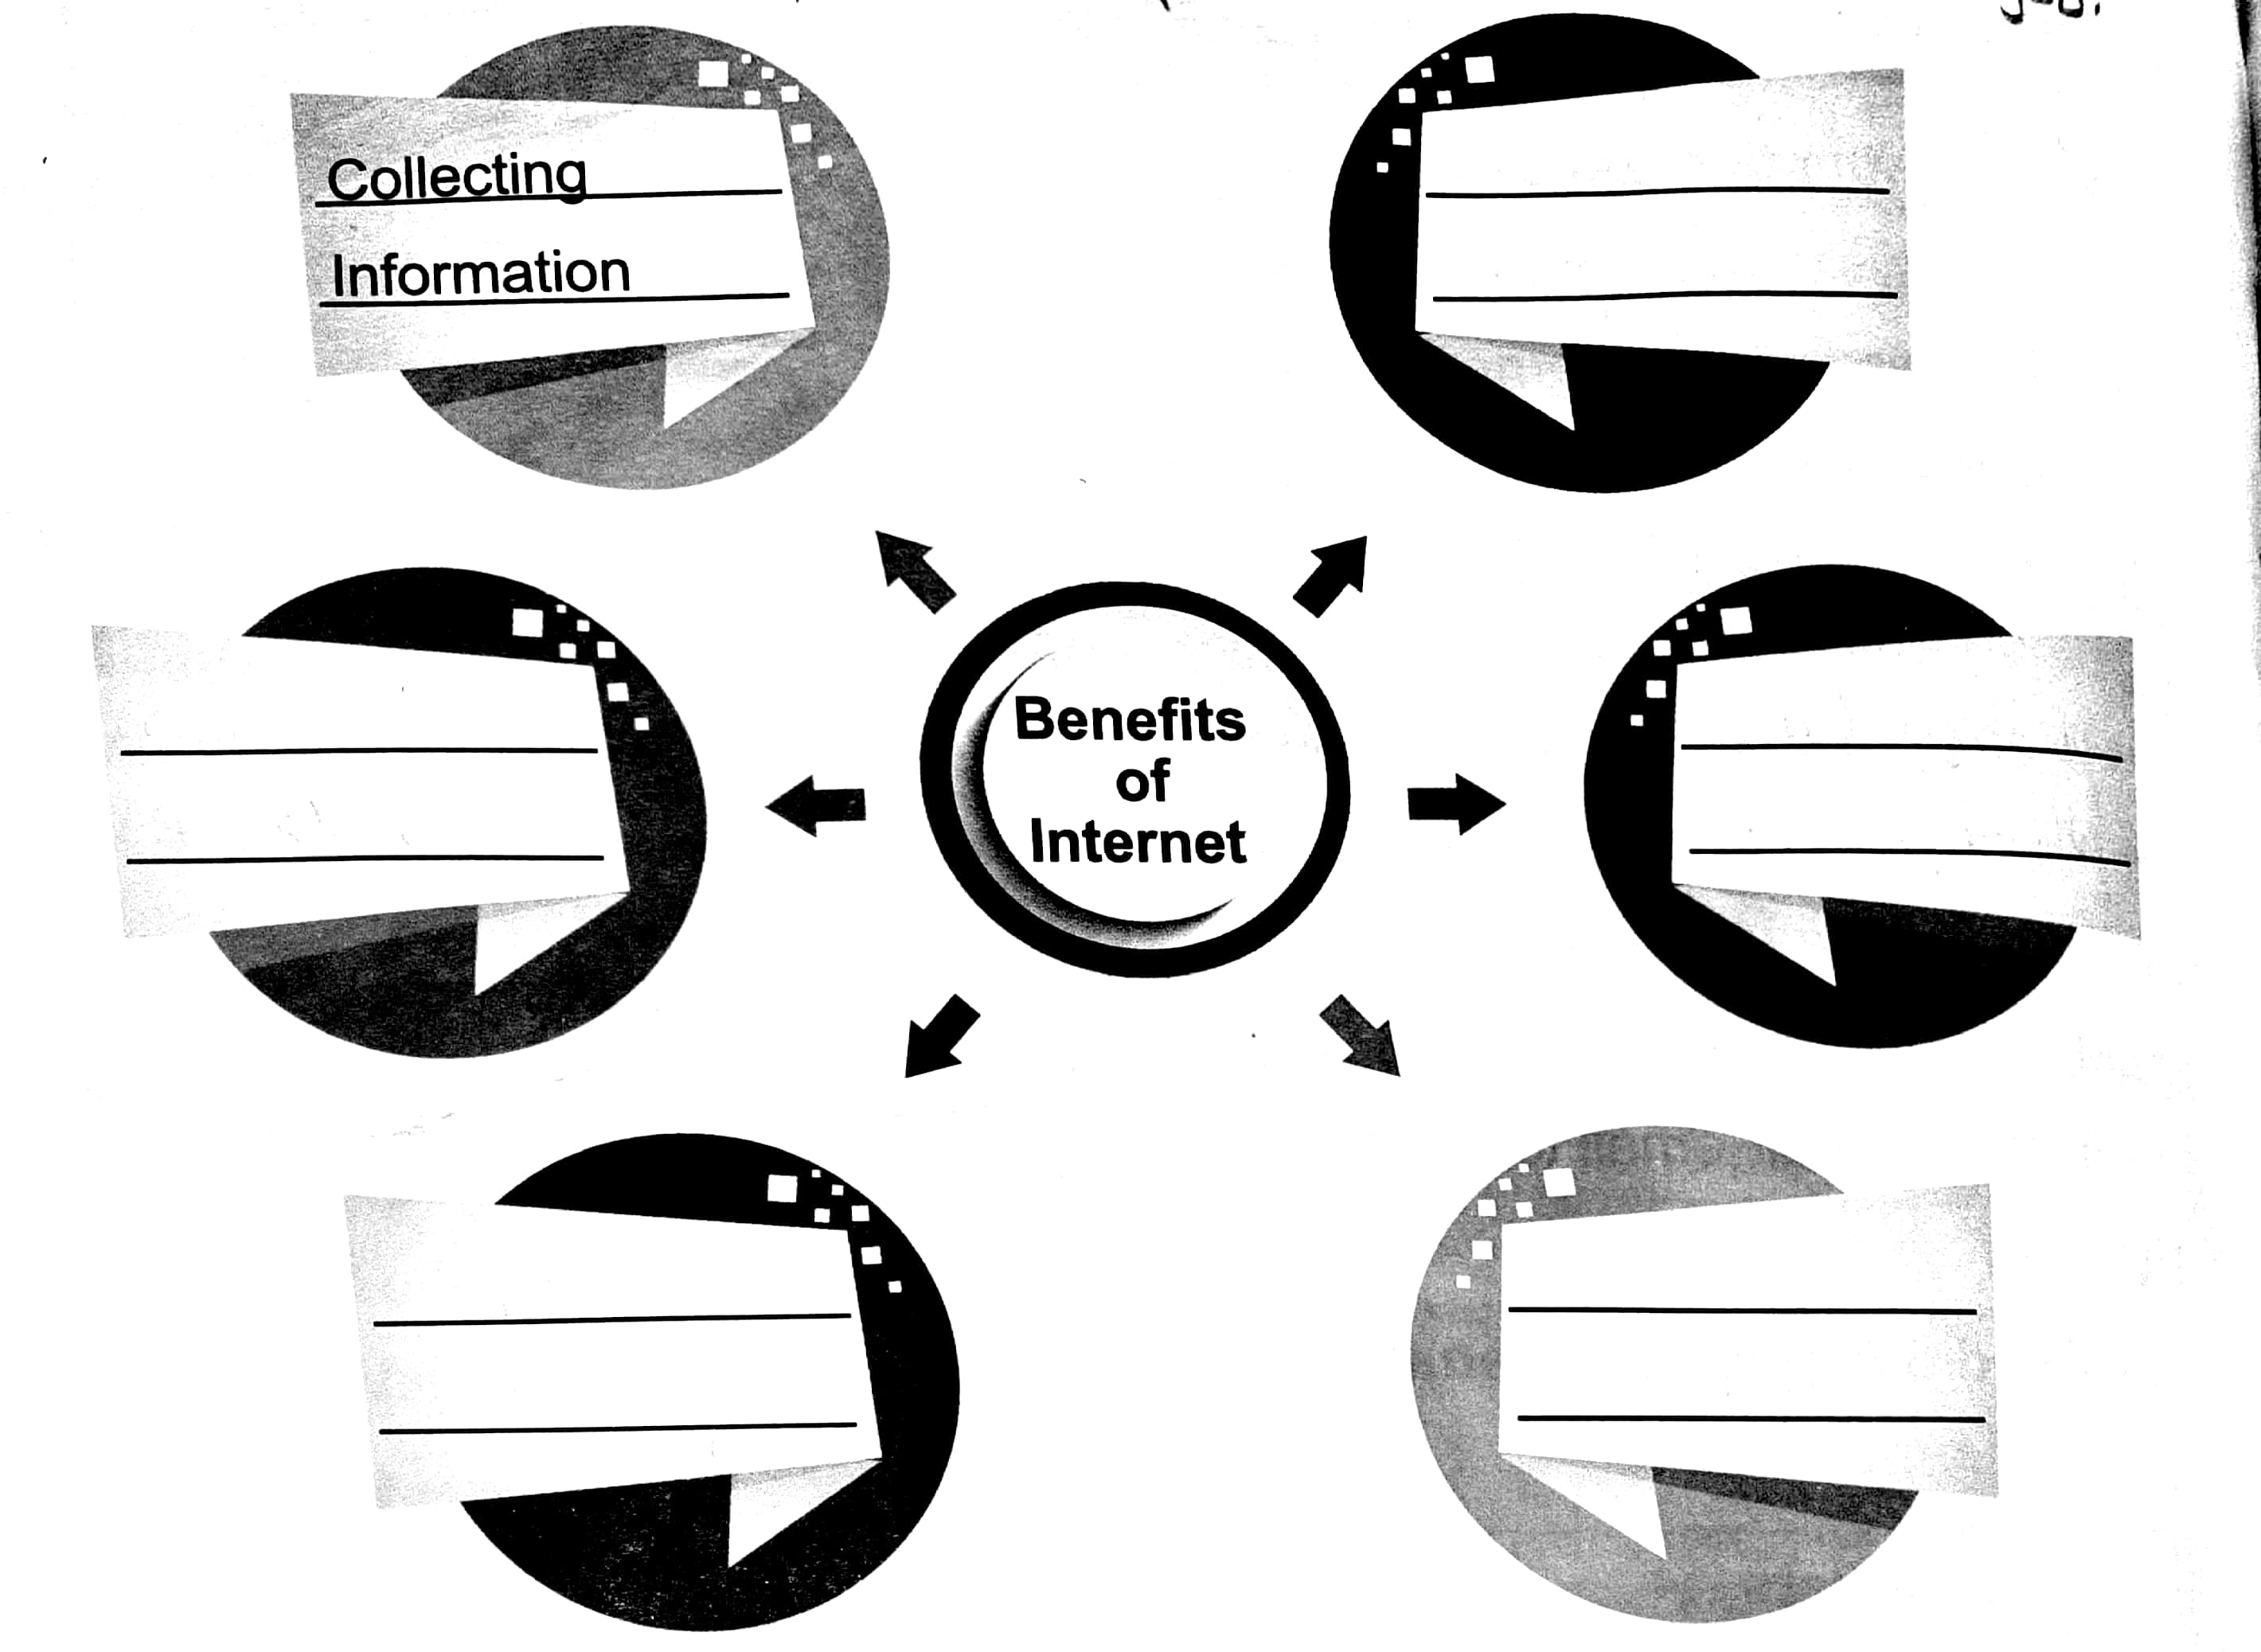
Q.no.7 Write the homophones for each of the given words. /4
Break
Right
Not
Tale

Q.no.8 Time to Think /5
Difference between lunar year and solar year.
Lunar year | Solar year

Q.no.9 Write a sentence using each of the given punctuation marks. /5
1. Full stop:_______________________________________________________
2. Question mark:__________________________________________________
3. Exclamation mark:________________________________________________
4. Comma:_______________________________________________________
5.Capitalisation:___________________________________________________
Q.no.10 Creative writing ______________________________. /5
_____________________________________________________________________________
_____________________________________________________________________________
_____________________________________________________________________________
_____________________________________________________________________________
_____________________________________________________________________________
_____________________________________________________________________________
_____________________________________________________________________________
_____________________________________________________________________________
_____________________________________________________________________________
_____________________________________________________________________________

Dictation: /10
Words | Meanings

