1.Table oral 05/
Subject: __Maths___________ Total Marks: ___50_______
Month : __ October_ ___ Obt. Marks: ___________
Theme/Unit: _page#89 to page #144 Grand total:____45+5_____
Objective/subjective:__________ Student ID : _________
Name ____________________ class: _2nd__ Section: ____________
2.Encicle the correct Answer. 1×10=10/
- What is the symbol of division?
. A. + B. ÷ C. - D. ×
- Division means repeated__________.
A.additiin B. Subtraction C. Division D. Multiplication
- A fraction shows part of a whole which is divided into__________parts.
A.zero B. Equal C. Unequal. D. Opposite
- Which of these shows one quarter?
A.1/2. B.1/3. C. 1/4 D. 1/5
- Four ________make one whole.
A.halves. B.third C. Fourth D. Fifth
- _______is the standard unit of length?
A .width. B.lenght. C.volume. D.mass
- How many grams(g) in one kilograms(kg)?
A .1000. B. 100 C.10000. D. 10
- One of the standard units of length?
A.pebble B. Meter C. handspan. D.jug
- The amount of liquid a container can hold?
A.mass B. Length C. Capacity D.width
10. 20÷1=_________.
A.0 B. 1 C. 10 D.20

2.Solve the following. 08/
- 5 5cm b) 7 9cm

+2 3cm - 3 8cm
________ ___________

c)7 1kg d)4 9kg
+2 2kg -1 9kg
___________ ___________

4. Hina used a 5m lace for her shirt and a 4 m lace for her scarf.How much lace did she use altogether? 05/
_____________________________________________= m

_____________________________________________= + m

_____________________________________________= m

5.Define the following. 3+3=6
A)Fraction

B) Capacity

6.Answer the following questions. 2 ½+2 ½ =05/
A)How many quarts make one half?

B)List a few things which are measured in kilograms?

Q# 7: What unit will be used to measure following objects. /2

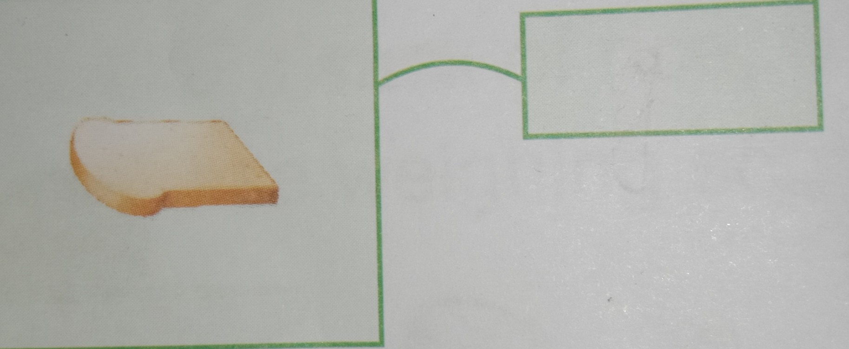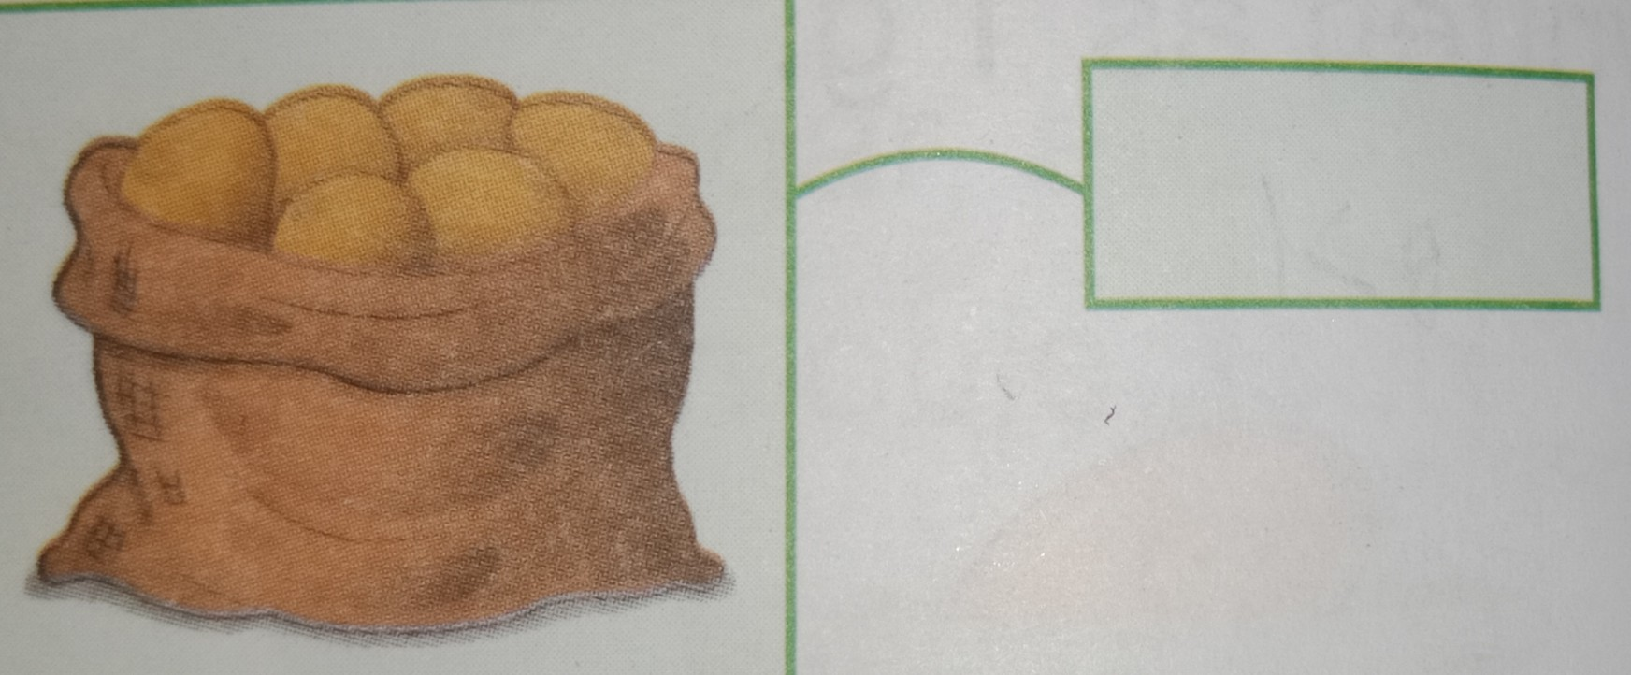

Q# 8: Compare the capacity of following containers. /3

The capacity of pan is __________ cups.

The capacity of pot is ___________ cups.
The capacity of pot is ____________ than capacity of pan.

9.Divide the following /5
  - 40÷4=______
  - 16÷2=______
  - 24÷4 =_______
  - 9÷3 =_______
  - 30÷10=________
10.Look at the fractions and colour the shapes according to the fractions. 06/

