Subject: ______ English______ Total Marks: ________ 52____
Month Test: __ __JUNE ___ Obt. Marks: ________________
Theme/Unit: ________ _______ Grand total:______ 100 ______
Subjective __________________ ID: ____________________
Name: ______________________ class:__5th Section: _________________
Q#1 . Answer these following questions. / 10

1. What is most pleasant thing a child can do, according to the poet ? ( the swing )

2.what advise does the mother give to her children?

____________________________________________________________

3. Where was the provisional exhibition held?

____________________________________________________________

____________________________________________________________

4. How did Fatima jinnah support her brother Muhammad Ali jinnah ?

____________________________________________________________

____________________________________________________________

5.What was the role of Fatima jinnah in the Pakistan Movement?

____________________________________________________________

____________________________________________________________

Q#2.Write meanings of these words . /3

Significant ____________________

Pleasant ____________________

Mesmerising ______________________

Q#3.Define Antonym /2
____________________________________________________________

____________________________________________________________

Q#4. Write ten compound words. /5

1 .______________________ 2. .______________________

3 .______________________ 4. _____________________

5. ______________________ 6. ______________________

7. ______________________ 8._______________________

9. ______________________ 10._______________________

Q#5. Rewrite the following sentences using correct capitalization. /6

1.’ the foolish donkey ‘ is a moral story.

____________________________________________________________

Sana is reading ‘ the very hungry caterpillar ’.

____________________________________________________________

3.Raheel bought a new book .it's title is ‘wild animals’.

____________________________________________________________

Q#6. Name the different swings shown in the picture. /2

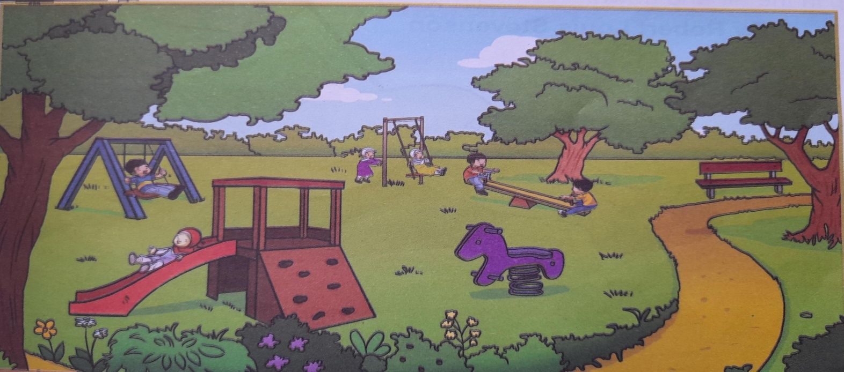
___________________________________________________________

Q#7. Change the following parts of speech by adding ’ ly ‘ ion’ and ‘able’. /5

- Direct ________________________

- Excited ________________________

- Manage ________________________

- Notice ________________________

- Creative ________________________

Q#8. Write a paragraph on ‘ A great day with a friend ‘ . /5

___________________________________________________________

___________________________________________________________

___________________________________________________________

___________________________________________________________

___________________________________________________________

___________________________________________________________

___________________________________________________________

Q#9. Creative writing …………………………… /5

___________________________________________________________

___________________________________________________________

___________________________________________________________

___________________________________________________________

___________________________________________________________

___________________________________________________________

_________________________________________________________

___________________________________________________________
Q#10. The pie chart below provides information about what grades 5 students like to eat. look at the pie chart and answer the given questions. /6
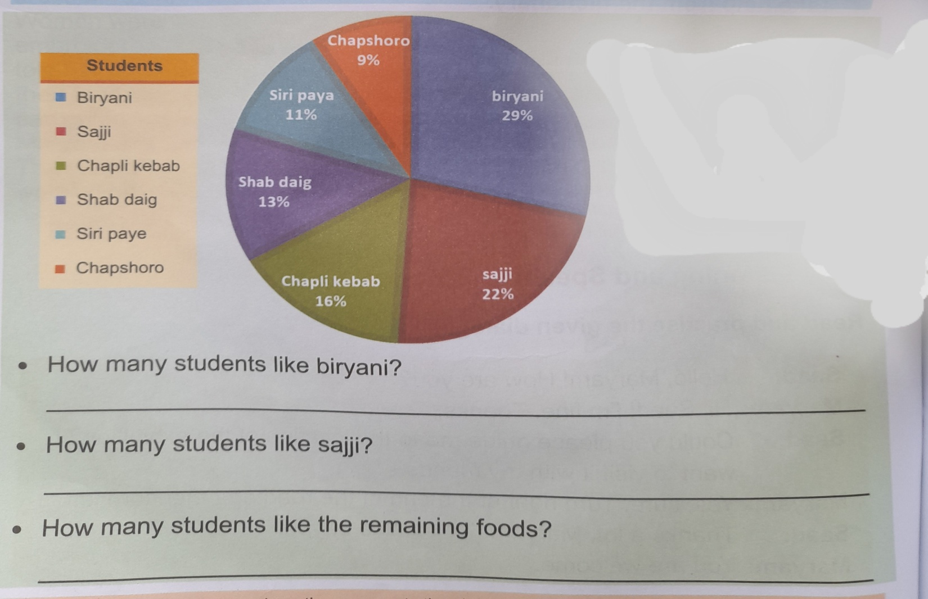

Q#11. Reti sentences using the nouns in their plural forms. /3

- The deer is grazing in the field.

- _________________________________________________________
- There is a fish in the pond.

_________________________________________________________

- There is a grapefruit in the basket.

_________________________________________________________

Q#12. Dictation . /10

