Q.no.1 Answers the following questions. 10/
Subject: _______ S.St________ Total Marks: ______/52 _____
Month Test: __ __august ___ Obt. Marks: ________________
Theme/Unit: ____ch 1 to 5_______ Grand total:_____/100 ______
Subjective:____________________ ID: ____________________
Name: ______________________ class: _5th Section: _________________
1. Write any three rights of a responsible citizen.
__________________________________________________________________________________________________________________________________________________________
2. In which fields do we use computers and the Internet?
__________________________________________________________________________________________________________________________________________________________
3. Name different cultural groups in Pakistan.
__________________________________________________________________________________________________________________________________________________________
4. How can we overcome a conflicting situation?
__________________________________________________________________________________________________________________________________________________________
5. List three social media apps.
__________________________________________________________________________________________________________________________________________________________

Q.no.2 Describe the importance of the rule of law with an example. 5/
__________________________________________________________________________________________________________________________________________________________
__________________________________________________________________________________________________________________________________________________________
_____________________________________________________________________________
_____________________________________________________________________________
__________________________________________________________________________________________________________________________________________________________
Q.no.3 Difference between social media and mass media.Give examples of both. /5
_____________________________________________________________________________
__________________________________________________________________________________________________________________________________________________________
_____________________________________________________________________________
_____________________________________________________________________________
_____________________________________________________________________________
__________________________________________________________________________________________________________________________________________________________

Q.no.4 Explain the concept of nationalism. 5/
_____________________________________________________________________________
__________________________________________________________________________________________________________________________________________________________
_____________________________________________________________________________
_____________________________________________________________________________
__________________________________________________________________________________________________________________________________________________________
_____________________________________________________________________________
__________________________________________________________________________________________________________________________________________________________

Q.no.5 When and why world children’s day celebrated? /5
_____________________________________________________________________________
__________________________________________________________________________________________________________________________________________________________
_____________________________________________________________________________
__________________________________________________________________________________________________________________________________________________________
_____________________________________________________________________________
__________________________________________________________________________________________________________________________________________________________

Q.no.6 What is etiquette? List some etiquette in your own words. /5
_____________________________________________________________________________
__________________________________________________________________________________________________________________________________________________________
_____________________________________________________________________________
_____________________________________________________________________________
_____________________________________________________________________________
__________________________________________________________________________________________________________________________________________________________

Q.no.7 How many languages are spoken in the world? /5
_____________________________________________________________________________
__________________________________________________________________________________________________________________________________________________________
_____________________________________________________________________________
__________________________________________________________________________________________________________________________________________________________
_____________________________________________________________________________
__________________________________________________________________________________________________________________________________________________________

Q.no.8 Names of any four newspapers published in Pakistan. Write them below. /4

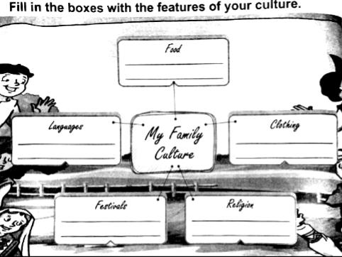
Let’s try it………… /8

