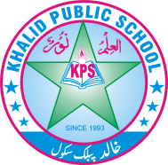
Subject: _______ Science ________ Total Marks: ___30__ _____
Month Test: __ __JUNE ___ Obt. Marks: ________________
Theme/Unit: ________ _______ Grand total:_____50_ ______
Objective:____________________ ID: ____________________
Name: ______________________ class: ___ 4th Section: _________________
Q) :4 Write the answers. /10
Q)1. Compare how the stem of big trees are different from small trees?
Ans________________________________________________________________________________________________________________________________________________________________________________
Q)2 why are plants called produces? Ans:_______________________________________________________________________________________________________________________________________________________________________________
Q)3 write some uses of metals?
Ans:_______________________________________________________________________________________________________________________________________________________________________________
Q)4 Define transfermission of energy with two examples?
Ans_______________________________________________________________________________________________________________________________________________________________________________
Q)5 list the components of a circuit?
Ans:_____________________________________________________________________________________________________________________________________________________________________________

Q:5 What kind of energy is stored in these objects? /5
Objects. Type of energy
Battery of UPS:. ____________________________
Parachute:. ____________________________
banana : ____________________________
spring ____________________________
coal: ____________________________

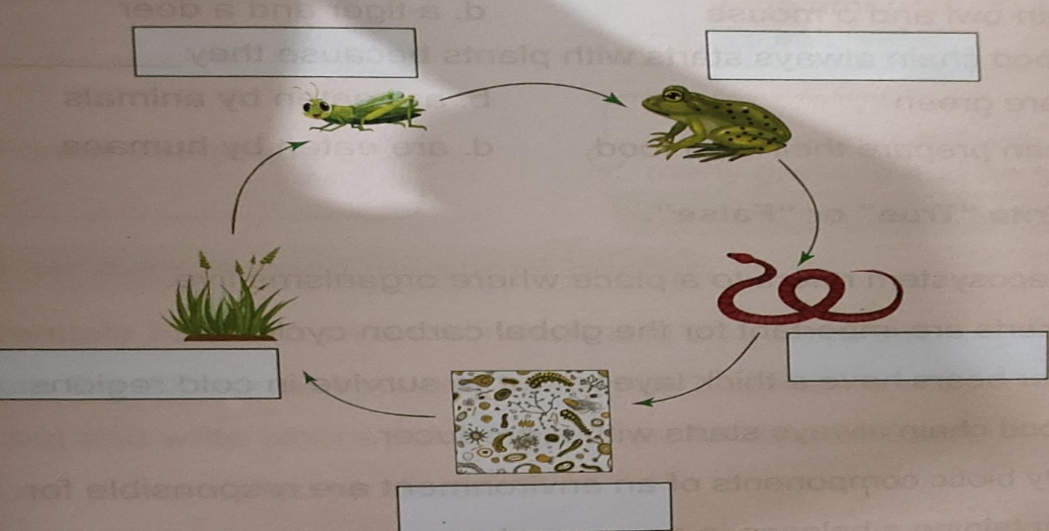
Q:6 Mentioned the names of each level of organisms in the given Food chain. /5

Q: 7 Long questions
Answer the questions. /15
Q1

Differentiate between flowering and on flowering plants with examples? /5

_________________________________________________________________________________________________________________________________________
_________________________________________________________________________________________________________________________________________
_________________________________________________________________________________________________________________________________________

Q2 What is buoyancy ? which objects floats on water? /5
_________________________________________________________________________________________________________________________________________
_________________________________________________________________________________________________________________________________________
_______________________________________________________________________________________________________________________________________

Q3 explain how we can conserve energy. /5

_________________________________________________________________________________________________________________________________________
_________________________________________________________________________________________________________________________________________
_________________________________________________________________________________________________________________________________________

