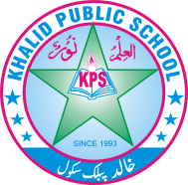
Subject: _______ Science ________ Total Marks: ____20__ _____
Month Test: __ __JUNE ___ Obt. Marks: ________________
Theme/Unit: ________ _______ Grand total:_____50_ ______
Objective:____________________ ID: ____________________
Name: ______________________ class: ___ 4th Section: _________________

Q: 1 Circle the correct option. /10

- Cardiac muscles are found in_________.

  - Blood vessels. B) ureter. C) heart. D) elementary canal

- Plants make food with the help of ________ present in leaves.

  - Nectar. B) carbon dioxide. C) chlorophyll. D) oxygen

- A rich source of carbohydrates is ________.

  - Butter. B) rice c) sweets. D) milk

- Which of the following objects will float on water surface?

  - Rock. B) egg. C) spoon. D) plastic bottle

- Hydropower is the energy we get from______.

  - Water. B) wind. C) oil. D) the sun

- Which of the following is cheapest source of energy?

  - Water. B) wind. C) natural gas. D) coal

- The device that is used to measure temperature is called a_________.

  - Thermometer. B) stethoscope. C) glucometer. D) ECG machine

- Splitting of white light into seven colors is called _______.

  - Reflection b) refraction. C) dispersion. D) absorption

- The first thermometer was invented around ______ years .

  - 1593. B) 1783. C) 1926. D). 2003

- Humans are made of ______ state of matter.

  - Four. B) two. C) one. D) three

Q:2 Match the column . /3

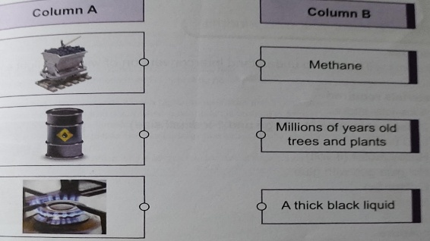

Q:3 Write “true ”. Or “false”. /5

- Flowing water is the ultimate source of energy. _____________

- Wood is good conductor of electricity. _______________

- Gems cannot transfer from food to our body. ______________

- All vertebrates have an exoskeleton. _________________

- There are five states of matter. ________________

Q:4 write the 2 names of non-flowering plants . /2

- ________________. 2) ________________

