Subject: ___English________ Total Marks: __42+10_____
Month Test: __ __JUNE ___ Obt. Marks: ________________
Theme/Unit: p#1 to 57____ Grand total:___50+10 ______
subjective:___________ ID: ____________________
Name: ______________________ class: ___4th Section: _________________
Q#2 (A) Compression Time(Questions and answers). /8
1:What is a leaflet?
__________________________________________________________________________________________________________________________________________________________________________
2:What is the central idea of the poem,"The Wind"?
__________________________________________________________________________________________________________________________________________________________________________
3:What is your ambition in life?
__________________________________________________________________________________________________________________________________________________________________________
4:Why there is a need for electrical cars?
__________________________________________________________________________________________________________________________________________________________________________

Q#3 Compression Time (Activity) /3
Write two words with each given digraph or trigraph.
Ch th tch
_________ ________ __________
_________ _________ ___________

Q#4 B Time to Think /4
Search the internet and read about different seasonal fruits eaten in winter and summer.List down their name.
__________________________________________________________________________________________________________________________________________________________________________
__________________________________________________________________________________________________________________________________________________________________________
__________________________________________________________________________________________________________________________________________________________________________

__________________________________________________________________________________________________________________________________________________________________________
__________________________________________________________________________________________________________________________________________________________________________

Q#5 B Grammar /4
Rewrite the given phrases and sentences with correct punctuation.
1:sadias room
__________________________________________________________________
2:my uncle house
__________________________________________________________________
3:what a cute white cat
__________________________________________________________________
4:wow this dress is really nice
__________________________________________________________________
Q#6 While Reading. /2
Guess the meaning of the word "sustain"?
__________________________________________________________________________________________________________________________________________________________________________

Q#7 B Creative writing from the book. /4
Write a paragraph on "why we should grow more trees".
__________________________________________________________________________________________________________________________________________________________________________
__________________________________________________________________________________________________________________________________________________________________________
__________________________________________________________________________________________________________________________________________________________________________
__________________________________________________________________________________________________________________________________________________________________________
__________________________________________________________________________________________________________________________________________________________________________
__________________________________________________________________________________________________________________________________________________________________________
__________________________________________________________________________________________________________________________________________________________________________

Q#8 (A) Phonic practice. /2
Circle the consonant clusters in initial position in the given words.
Scream
Stream
Three
Sprinkle
Q#9 Write a Define of "Masculine". /2
__________________________________________________________________________________________________________________________________________________________________________
__________________________________________________________________________________________________________________________________________________________________________
Q#10 Let's get started /2
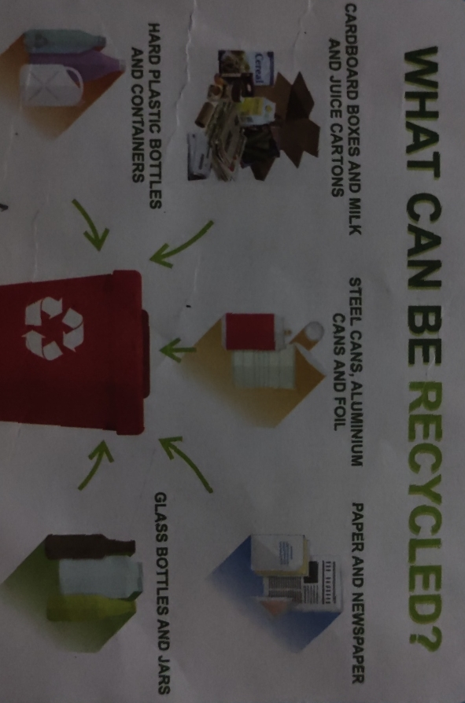
Q:What is recycling?
A:________________________________________________________________________________________________________________________________________________________________________
Q#11 Activity. /2
Write the comparative and superlative degrees of the given adjectives.
Positive Comparative Superlative
Close _________________ ________________
Sweet _________________ ________________
Busy _________________ ________________
Large _________________ _________________
Q#12 Vocabulary (Write meanings of the given words) /2
Bow ________________
Climate ________________
Rubbish ________________
Pollution ________________
Q#13 Aspects of language /2
Provide a homophone for each of the given words.
Break _____________
Right _____________
Ate _____________
Tail _____________
Q#14 A Guided writing. /3
Write a paragraph on your daily routine.Remember to use conjunctions and transitional devices.
__________________________________________________________________________________________________________________________________________________________________________
__________________________________________________________________________________________________________________________________________________________________________
__________________________________________________________________________________________________________________________________________________________________________
__________________________________________________________________________________________________________________________________________________________________________
__________________________________________________________________________________________________________________________________________________________________________
__________________________________________________________________________________________________________________________________________________________________________
__________________________________________________________________________________________________________________________________________________________________________
Q#15 Creative writing (_________________). /2
__________________________________________________________________________________________________________________________________________________________________________
__________________________________________________________________________________________________________________________________________________________________________
__________________________________________________________________________________________________________________________________________________________________________
__________________________________________________________________________________________________________________________________________________________________________
__________________________________________________________________________________________________________________________________________________________________________
__________________________________________________________________________________________________________________________________________________________________________
Q#16 Dictation 10

