Qno.3.Answer the following question briefly. 3*5. /15.
Subject: _______ _science_______ Total Marks: _____52
Month Test: __ __JUNE ___ Obt. Marks: ________________
Theme/Unit: _____1A to 6A.___ _______ Grand total:___100____
Subjective.________________ ID: ____________________
Name: ______________________ class: ___ 5th Section: ___________
- Describe classification in your own words.
Ans.____________________________________________________________

- What is infection?
Ans _____________________________________________________________

3.Write down the major parts of a flower?
Ans._____________________________________________________________

4.What is incineration ? What are it’s effects.
Ans._____________________________________________________________

________________________________________________________________.

5.What. Are luminous objects?write the names of any two.
Ans.____________________________________________________________

Qno.4. Differentiate between:. 5*2. /10.
(A).Boiling and evaporation.

(B). Biodegradable and non_ biodegradable materials.

Qno.5. Answer the following questions in detail .
1.light travel in a straight line .Explain this with an experiment. /6
Ans.________________________________________________________________

2.Explore how birds are different from other vertebrates. /4
Ans._________________________________________________________________________________________________________________________________________________________________________________________________________________________________________________________________________________

- Explain the effects of land and water pollution on the environment?. /5
Ans.__________________________________________________________________________________________________________________________________________________________________________________________________________________________________________________________________________________________________________________________________________________________________________________________________________________________________________________________________________________________________________________________________________________________________.

Qno 6.Activity. /5.
Fill in the table.

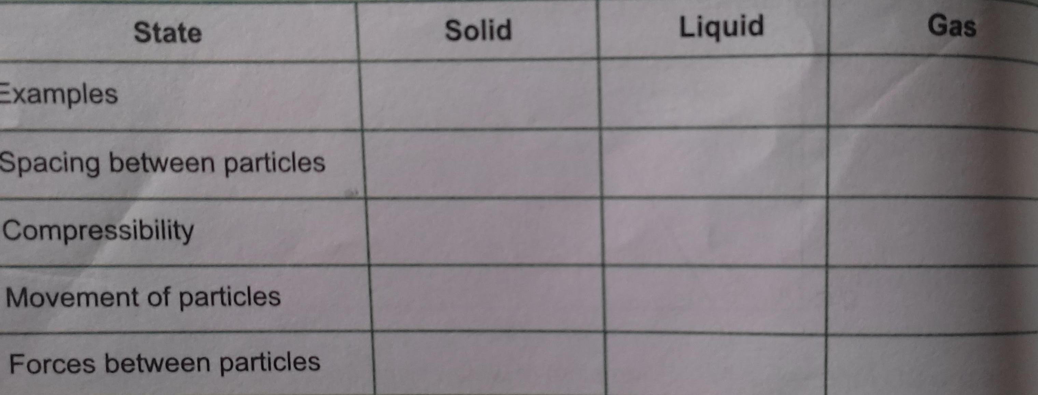

Qno.7. label it. /4.

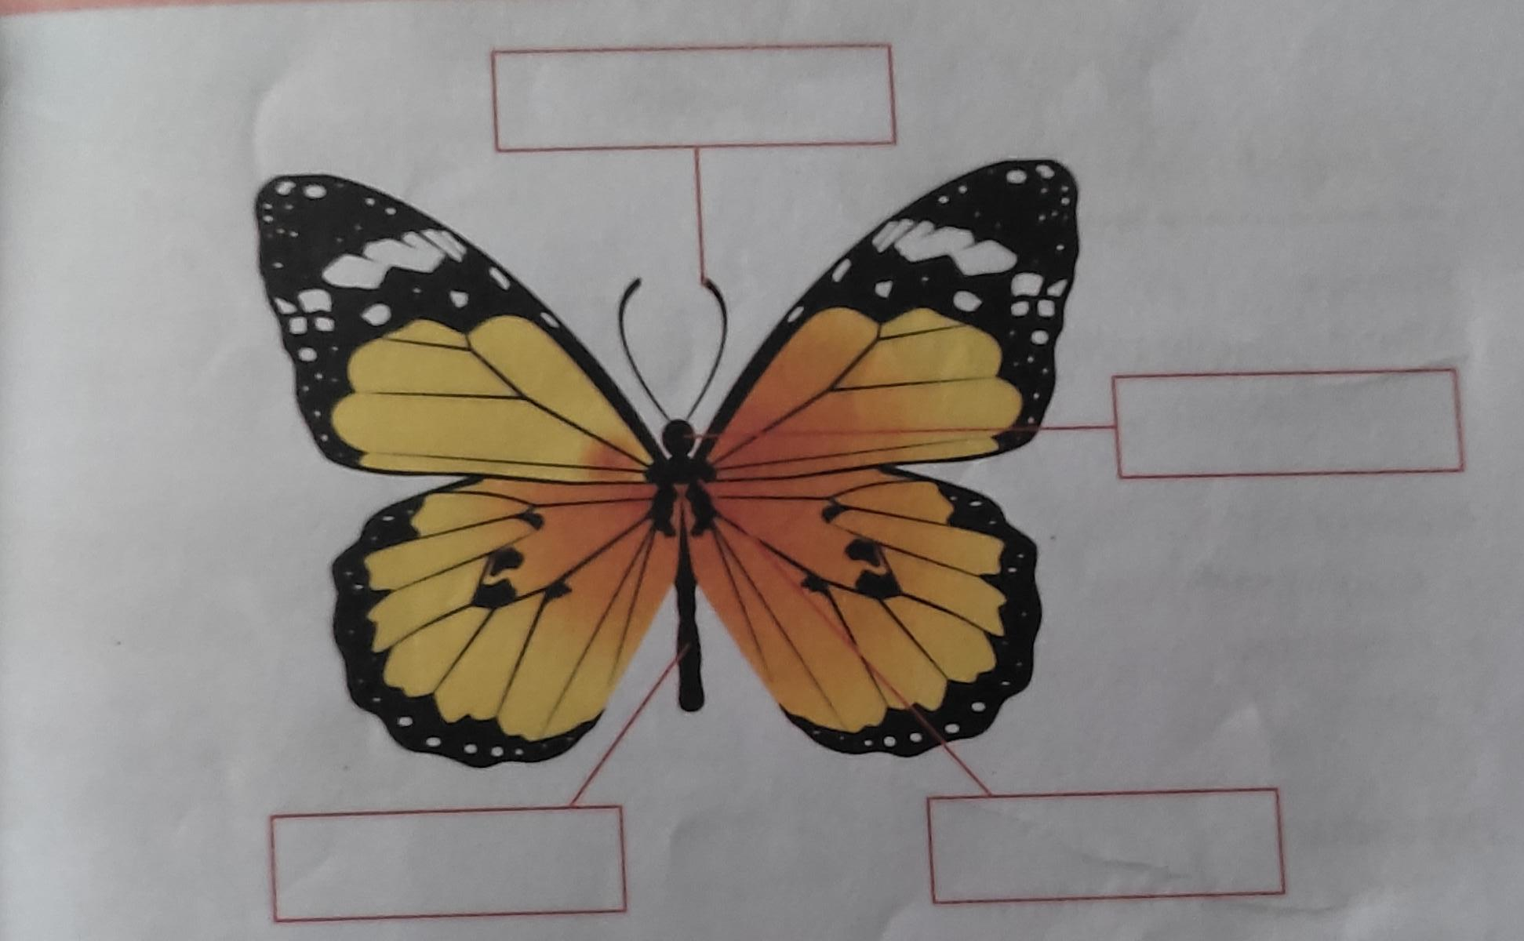
Qno.8.
Science tit bit. /3
Q.How many indicators of a chemical change have?.
Ans.__________________________________________________________________________________________________________________________________________________________________________________________________________.

